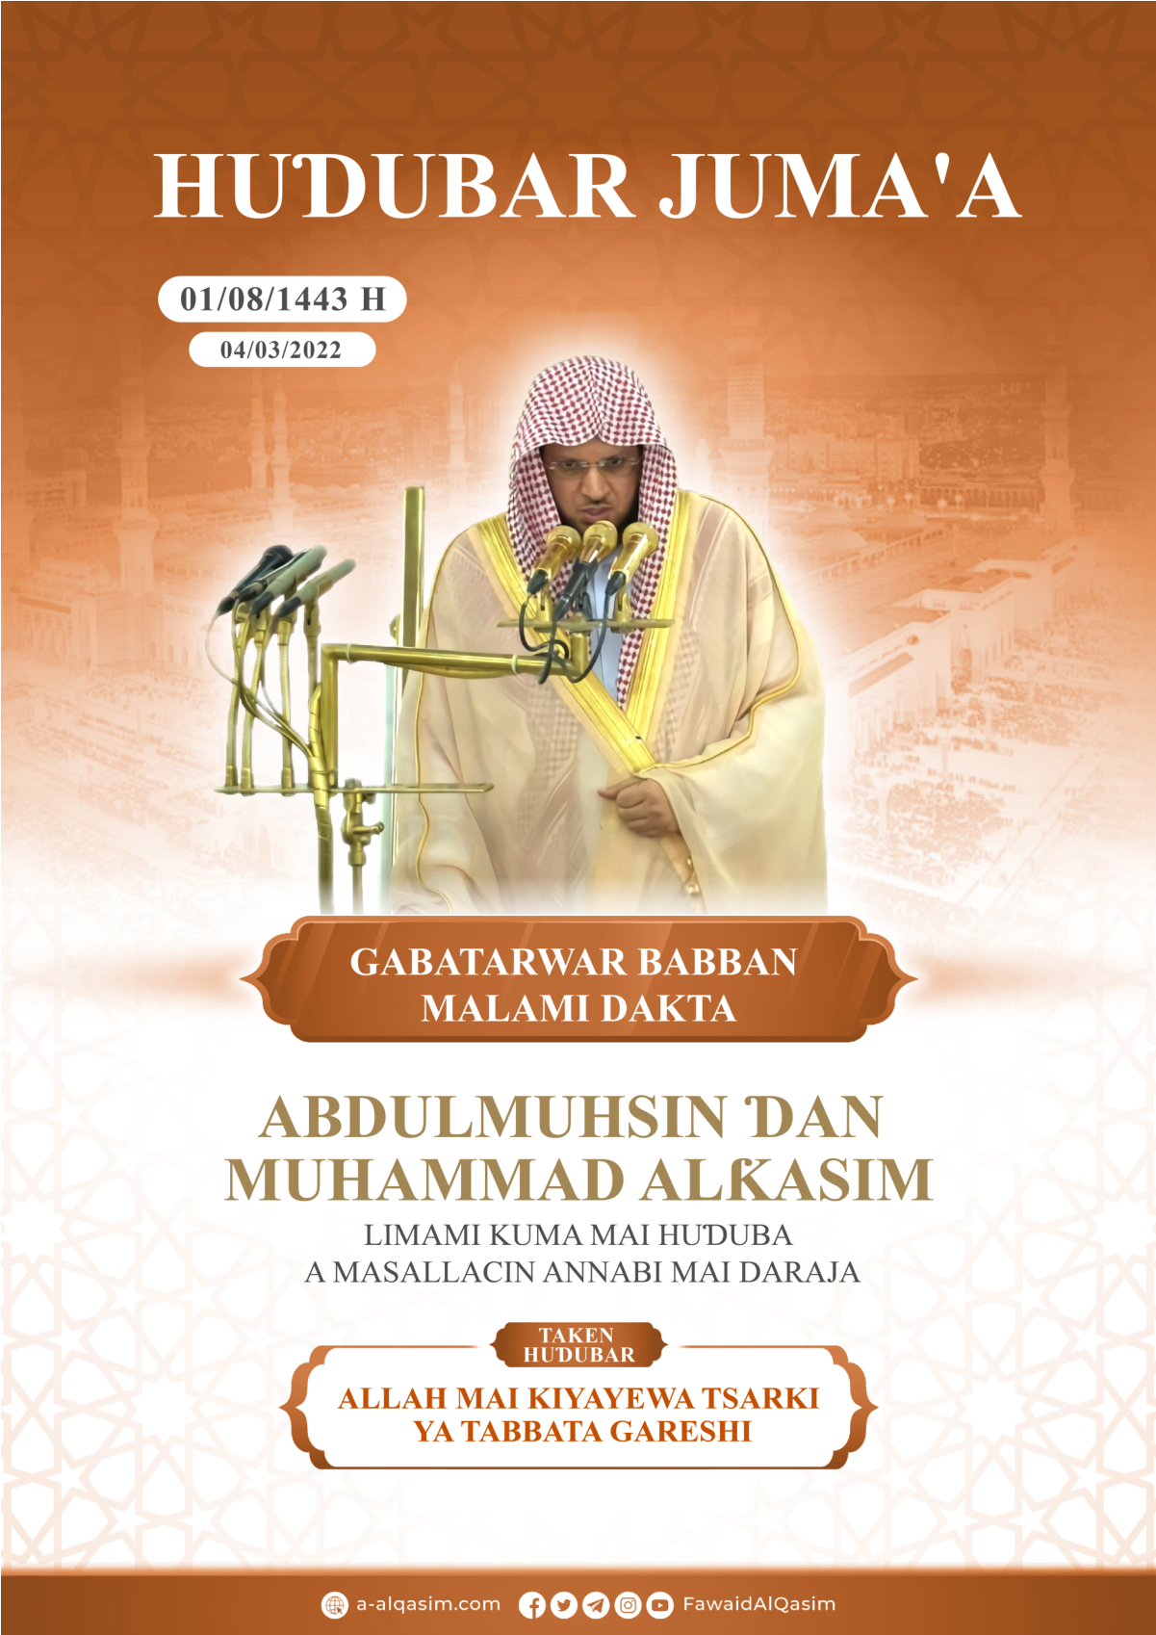
Allah Mai Kiyayewa Tsarki Ya Tabbata Gareshi⁽⁾
Dukkan godiya sun tabbata ga Allah, muna gode maSa, kuma muna neman taimakonSa, kuma muna neman gafararSa, kuma muna neman tsarin Allah daga sharrukan kawunanmu, da kuma zunubban ayukkanmu, wanda Allah Ya shiryar dashi, to babu mai ɓatar dashi, kuma wanda Ya ɓatar to babu mai shiryar dashi, kuma ina shaidawa babu Abin bautawa da gaskiya sai Allah, Shi kaɗai baShida abokin tãrayya, kuma ina shaidãwa Annabi Muhammad bãwanSa ne kuma ManzonSa ne, yabo da amincin Allah su tabbata a gare shi, da iyalansa da kuma sahabbansa, kuma yayi aminci, aminci mai yawa.
Bayan Haka:
To kuji tsoron Allah - yã ku bayin Allah- haƙiƙanin jin tsoro, kuma ku kiyaye Shi cikin sirri da gãnawa.
Yã ku Musulamai:
Allah Maɗaukaki Yanada sunaye mafiya kyawu, wanda suka ƙunshi siffofi mafiya kamãla kuma mafiya ɗaukakarsu, kuma sunayen Allah da siffofinSa sashinsu suna nuni zuwa ga sashi, kuma mutane suna bambanta da juna a cikin bauta da kusanci zuwa ga Allah da gwargwadon saninsu ga sunayenSa da siffofinSa, daga cikin sunayenSa akwai waɗanda indai har bãwa ya kiyayesu to da yã shiga Aljannah, kuma duk abinda ke cikin duniya na motsi ko natsuwa, to lallai su suna daga tasirin sunayenSa ne da siffofinSa, Allah Wanda sha`aninSa ya ɗaukaka Ya ce:
ﱡ ﭐ ﳑ ﳒ ﳓ ﳔ ﳕ ﳖ ﳗ ﳘ ﳙ ﳚ ﳛ ﳜ ﳝ ﳞ ﳟ ﳠ ﳡ ﳢ ﳣ ﳤ ﳥ ﳦ ﳧ ﳨ ﳩ ﳪ ﱠ [سورة الطلاق: 12].
«Allah Shine wanda ya halicci sammai bakwai, daga ƙasa ma ya halicci kwatankwacinsu, umurni yana sassauka tsakãninsu, domin ku sani cewa: lallai Allah Mai iko ne kan komai, kuma lallai Allah Ya kewaye komai da sani» [suratuɗ Ɗalãq: 12].
Kuma na daga sunayenSa –Madaukaki- da Ya sanyama kanSa, kuma Ya sananne wurin halittunSa dasu, «Mai matuƙar kiyayewa» da «Mai kiyayewa», Ya kiyaye abinda ya samar dashi na halittu da ikonSa, da bã don kiyayewarSa ba, da sun gushe sun rushe, da bã don kulawarSa ba, da tsarin halittu ya sakurkurce, kuma da sashinsu sunyi ƙeta ga sashi.
Domin sammai da ƙasa da abinda ke cikinsu, da kuma abinda ke tsakãninsu, suna tsayuwa ne da UmurninSa, Allah Wanda sha`aninSa ya ɗaukaka Ya ce:
ﱡ ﲁ ﲂ ﲃ ﲄ ﲅ ﲆ ﲇ ﲈ ﲉ ﲊ ﲋ ﲌ ﲍ ﲎ ﲏ ﲐ ﱠ [سورة فاطر: 41].
«Lallai Allah Yana riƙe da sammai da ƙasa, saboda kada su gushe, kuma idan da zasu gushe, babu wani mai iya riƙesu bãyanSa» [suratu Fãɗir: 41].
Kuma ya kiyayesu da abinda ke cikinsu, domin su wanzu iya lokacin wanzuwarsu su biyun bazasu gushe ba bazasu rushe ba, kuma kiyaye su abune mafi rashin wahala agare Shi, kuma mafi sauƙinsa.
ﱡ ﭐ ﳁ ﳂ ﳃ ﳄﳅ ﳆ ﳇ ﳈﳉ ﳊ ﳋ ﳌ ﱠ [سورة البقرة: 255].
«Kuma kujerarSa -wurin duga-dugai- ta yalwaci sammai da ƙasa, kuma kiyayesu baya nauyaya gare Shi, kuma Shine Madaukaki Mai girma» [suratul Baƙara: 255].
Kuma kiyayewarSa ta ƙunshi dukkan halittunSa, babu wani abu daga cikinsu da ya wadãtu daga kiyayewarSa dai-dai da ƙiftãwar ido,
ﱡﭐ ﲂ ﲃ ﲄ ﲅ ﲆ ﲇ ﱠ [سورة هود: 57].
«Lallai Ubangiji na Mai kiyayewa ne kan kowanne abu» [suratu Hudu: 57].
Kuma babu wani abu dake cikin sama, ko yake bisa doron ƙasa, ko ƙarƙashinta face shi kiyayayye ne cikin wani littafi,
ﱡﭐ ﱛ ﱜ ﱝ ﱞ ﱟ ﱠﱡ ﱢ ﱣ ﱤ ﱠ
[سورة ق: 4].
«Haƙiƙa Munsan abinda ƙasa ke tauyewa daga garesu, kuma a wurinMu akwai littafi mai kiyayewa» [suratu Qãf]. Ibnu Khatheer -Allah Ya jiƙansa- ya ce: «Watau: Haƙiƙa Mun san abinda ƙasa take ci daga gangar jikinsu a yayin ƙarewar rayuwa, Mun san haka, baya ɓoyuwa agareMu; a ina jukkunansu suka wawwatse? Ina suka tafi? Kuma zuwa ina suka kasance?».
Kuma yana daga kiyayewarSa ga bãyinSa: ta yadda ya wakilta wasu mala'iku akansu, masu maye gurbin juna ta gabansu da bãyansu suna kiyayesu daga cuta da
annoba da umurnin Allah,
ﱡﭐ ﲐ ﲑ ﲒ ﲓ ﲔ ﲕ ﲖ ﲗ
ﲘ ﲙ ﲚ ﱠ [سورة الرعد: 11].
«Yana da wasu –mala'iku- masu maye gurbin juna, ta gaba ga bawanSa da ta bayansa suna kiyayeshi bisa umurnin Allah» [suratur Ra'adi: 11].
Mujahid -Allah ya jiƙansa- ya ce: «Babu wani bawa, face yana da wani mala'ika da aka wakilta, yana kiyayeshi cikin barcinsa da farkawarsa daga aljanu da mutane da ƙwãri, babu wani abu daga cikinsu da zai zo masa yana nufarsa face sai yace: bayanka! Sai dai abinda Allah Yayi izini kansa cewa sai ya sameshi».
Kuma Yana kiyayema bayi dukkan ayukkansu kuma babu abinda ke ɓoyuwa agare Shi na maganganunsu, kuma Ya wakilta wani mala'ika ga kowanne mutum yana kiyaye aikinsa, ana lissafe masa abinda yake aikatawa na biyayya ko na saɓo,
ﱡﭐ ﱌ ﱍ ﱎ ﱏ ﱐ ﱑ ﱠ [سورة الطارق: 4].
«Babu wata rai, face akwai wani mai gãdi kanta». [suraɗ Ɗãriq: 4], kuma ita kiyãyayya ce cikin littattafan malã'iku kamar haka,
ﱡﭐ ﱯ ﱰ ﱱ ﱠ [سورة الانفطار: 10].
«Kuma lallai akwai wasu masu gãdi kanku» [suratul Infiɗãr: 10].
Kuma waliyyan Allah Annabawa -aminci ya tabbata a garesu- da mabiyansu; sunada wata kiyayewa ta musamman, domin Shi Allah Mai tsarki Yana kiyaye su daga abinda zai cutar da imaninsu, ko ya girgiza yaƙininsu na daga shubuhohi da fitintinu da sha'awoyi, kuma yana kiyayesu daga jinsin aljani da mutum, sai ya taimakesu akansu, Ya kautar da kutunguilarsu daga garesu.
Kuma wanda ya kiyaye umurce-umurcen Allah ta hanyar kamantawa, da hane-hanenSa da nisanta, kuma ya kiyaye iyakokinSa kuma bai ƙetaresu; Allah Zai kasance tare dashi cikin dukkan hãlin da yake ciki, ga duk inda ya fuskanta, Zai kewayeshi Ya taimakeshi, sai Ya kiyaye masa Addininsa daga shubuhohi da sha'awoyi, kuma Ya kiyaye masa duniyarsa, kuma Ya kiyayeshi cikin iyalansa kuma ya kiyaye masa Addininsa a yayin mutuwa, sai ya karɓi ransa bisa Imani, yabo da amincin Allah su tabbata a gare shi ya ce: «Ka kiyayi Allah Zai kiyayeka, ka kiyayi Allah zaka sameShi gaba gareka- ko gabanka-» [At-tirmizi ya ruwaito shi].
Kuma Annabawan Allah Maɗaukaki sun isar da saƙonnin Ubangijinsu, kuma sun tsai da Addinin da Allah Ya yarda dashi ga bãyinSa, Kuma saboda haka suka haɗu da tsanani da wahal-halu, kuma mafakarsu yayin haka shine Allah Mai kiyayewa -tsarki ya tabbata agare Shi, sai Ya kiyaye su, Ya kãre su daga karkacewa wajen Isar da saƙo, kuma an cutar dasu sai Ya kiyayesu daga makircin maƙiyansu.
An jefa Ibrahim –aminci ya tabbata a gare shi- cikin wata wuta mai girma da bata barin wani abu da takai gare shi face ta ƙoneshi, sai ya dogara ga Allah Mai tsarki, yace: «Allah yã isar mana, mãdalla da abin dogaro», sai Allah Ya tseratar dashi daga gareta, sai wutar ta zama sanyi da aminci a gare shi.
Kuma Isma'il –aminci ya tabbata a gare shi- Mahaifinsa ya kwantar dashi don ya yanka shi, kamar yadda Ubangijinsa ya umurceshi, to yayinda suka miƙa ga umurnin Allah suka gasgata mafarkin, yacema mahaifinsa:
ﱡﭐ ﳚ ﳛ ﳜﳝ ﳞ ﳟ ﳠ ﳡ ﳢ ﳣﱠ
[سورة الصافات: 102].
«Ka aikata abinda aka umurceka, da sannu zaka sameni in Allah ya yarda cikin masu hakuri» [suratus Sãffãt: 102]; sai Allah Mai kiyayewa Ya fansheshi da abin yanka mai girma.
Kuma Hudu –aminci ya tabbata a gare shi- yakira mutanensa, yayinda suka juya baya daga gare shi, kuma suka yi masa gargaɗi da cutarwa ya fake wurin Ubangijinsa Allah Mai kiyayewa, sai yace:
ﱡﭐ ﱱ ﱲ ﱳ ﱴ ﱵ ﱶ ﱷ ﱸﱹ ﱺ ﱻ ﱼ ﱽ ﱾ ﱿ ﲀﲁ ﲂ ﲃ ﲄ ﲅ ﲆ ﲇ ﱠ [سورة هود: 57].
«To idan suka juya baya, -kace- to haƙiƙa na isar muku da abinda aka aikoni dashi zuwa gareku, kuma Ubangijina Zai maye da wasu mutanen da bãku ba, kuma baza ku cutar dashi da wani abu ba, lallai Ubangiji na Mai kiyayewa ne kan kowanne abu». [suratu Hudu: 57]. Watau: yana kiyaye ni daga sharrinku da makircinku, da kuma daga ku shafeni wani mummuna.
Kuma kiyayewar Allah tãfi cika daga kiyayewar mutum, ƴan-uwan Yusuf -aminci ya tabbata a gare shi- sun jingina kiyaye Yusuf ga kawunansu, suka cewa mahaifinsu:
ﱡﭐ ﲲ ﲳ ﲴ ﲵ ﲶ ﲷ ﲸ ﲹ ﱠ
[سورة يوسف: 12].
«Ka aikashi tare damu gobe, ya sarãra kuma ya shaƙata, lallai mu masu kiyayewa ne gare shi» [suaratu Yusuf: 12], sai suka ɓatar dashi, kuma yayinda Yãqub –aminci ya tabbata a gareshi- ya jingina kiyaye Yusuf da ɗan-uwansa ga Allah, sai yace:
ﱡﭐ ﱌ ﱍ ﱎﱏ ﱐ ﱑ ﱒ ﱠ [سورة يوسف: 64].
«To Allah Shine mafi alherin Mai kiyayewa, kuma shine mafi jin ƙan masu jin ƙai» [suaratu Yusuf: 12].
Allah Ya kiyayesu, ya maido dasu zuwa gareshi, kuma kyakykyawan ƙarshe ya kasance garesu, banda haka Allah Ya sanya Yusuf –aminci ya tabbata a gare shi- ya zama mai kiyaye haƙƙoƙin bayinSa, Yusuf yace game da kansa:
ﱡﭐ ﱪ ﱫ ﱬ ﱠ [سورة يوسف: 55].
«Lallai Ni Mai kiyayewa ne Masani» [suratu Yusuf: 12].
Kuma Mahaifiyar Musa –aminci ya tabbata a gare shi- ta jefa shi cikin kogi yana jãriri mai shan nono, bisa amincewa da kiyayewar Allah, sai Ubangijinsa Ya kiyaye shi, Ya raineshi a idonSa a gidan maƙiyinsa, kuma Ya sanya shi ya zama Annabi mai girman sha'ani daga cikin ma'abota azama daga cikin Manzanni.
Kuma Yunus –aminci ya tabbata a gare shi- babban kifi ya haɗiye shi, a cikin duhun cikin babban kifi da kogi, da dare, sai ya kira Ubangijinsa Allah Mai kiyayewa,
ﱡﭐ ﲋ ﲌ ﲍ ﲎ ﲏ ﲐ ﲑ ﲒ ﲓ ﲔﱠ [سورة الأنبياء: 87].
«Cewa babu abin bautawa da gaskiya face Kai, tsarki ya tabbata gareKa, lallai ni na kasance daga cikin masu zalumci» [Suratul Anbiya'i: 87], sai Ubangijinsa ya Amsa masa Ya tseratar dashi daga baƙin ciki, kuma kamar haka ne Allah yake tseratar da muminai, bai ɓace ba a wofance cikin farfajiyar ƙasa,
ﱡﭐ ﲞ ﲟ ﲠ ﲡ *
ﲣ ﲤ ﲥ ﲦ ﲧ ﱠ [سورة الصافات: 145-146].
«Sai Muka jefoshi kan farfajiyar ƙasa alhali shi yana hali na rashin lafiya * kuma Muka tsirar masa da bishiyar kabewa» » [Suratus sãfãt: 145-146] .
Sulaimana –aminci ya tabbata a gare shi- an bãshi mulki mai girma, Allah Ya hore masa aljanu da suke bin umurninsa, kuma suna yimasa abubuwan ban mamaki, kuma Allah Ya kasance Mai kiyayewa ne gare shi, daga kangarewarsu da cutarwarsu, Allah Wanda sha`aninSa ya ɗaukaka Ya ce:
ﱡﭐ ﱁ ﱂ ﱃ ﱄ ﱅ ﱆ ﱇ ﱈ ﱉﱊ ﱋ ﱌ ﱍ ﱠ [سورة الأنبياء: 82].
«Kuma daga cikin shaiɗanu akwai masu yi masa nutso, kuma suna wani aikin daban banda wannan, kuma Mun kasance Masu kiyayewa ne daga garesu» [suratul Anbiya'i: 82]. Ibnu Khatheer Allah ya jiƙansa ya ce: «watau: Allah Yana kareshi, da wani daga cikin shaiɗanun ya safeshi da wanin mummunan abu, ba haka bama; dukkansu suna cikin ikonSa da ƙarƙashin mulkinSa, babu wani daga cikinsu da zai yi karambanin matsowa gareshi da kusantarsa, ba haka bama; Shine ja ragamarsu, idan yaga dama ya saki, idan kuma Yaga dama Ya ɗaure wanda yaso cikinsu».
Kuma Isa –aminci ya tabbata a gare shi- yahudawa sun yi kai-komo wajen kasheshi, da kawar da Manzancinsa, sai Allah Ya ɗaukaka shi zuwa gare Shi yana raye, ya kareshi daga hannuwansu, kuma Ya fansheshi da wani mai kama dashi daga cikin maƙiyansa,
ﱡﭐ ﱩ ﱪ ﱫ ﱬ ﱭ ﱮ ﱯﱠ
[سورة النساء: 157].
«kuma basu kashe shi ba, kuma basu gicciye shi ba, sai dai an nuna musu makamancinsa ne» [suratun Nisaa'i: 157] .
Kuma Annabinmu Muhammadu -yabo da amincin Allah su tabbata a gare shi- Allah Ya cika Saƙonni dashi, kuma Ya ɗauki nauyin kareshi, sai Yace:
ﱡﭐ ﱺ ﱻ ﱼ ﱽ ﱠ [سورة المائدة: 67].
«Kuma Allah Zai kareka daga mutane» [suratul Ma'idah: 67], watau: zai kiyaye ka daga sharrinsu da makircinsu, Zai kiyaye Manzancinka da abinda kazo dashi.
Jabir –Allah yarda dashi- ya ce: «Mun taho tare da Manzon Allah -yabo da amincin Allah su tabbata a gare shi- har saida muka iso Zãtur riqã'i, mun kai ga wata bishiya mai inuwa, sai muka barta ga Manzon Allah -yabo da amincin Allah su tabbata a gare shi-, sai wani mutumi daga cikin mushirikai yazo alhali takobin Manzon Allah –yabo da amincin Allah su tabbata a gare shi- na rataye da bishiya, sai ya ɗauki takobin Annabin Allah –yabo da amincin Allah su tabbata a gare shi- sai ya tuɓeshi –watau ya zaroshi daga gidansa- sai yace ga Manzon Allah –yabo da amincin Allah su tabbata a gare shi- shin kana tsoro na? yace: A'a, yace: to wa zai kare ka daga gareni?, sai yace: Allah Zai kare ni daga gareka, sai ya rufe takobin, ya rataye shi». [Bukhari da Muslim suka ruwaito shi].
Kuma mabiya Annabi -tsira da amincin Allah su tabbata a gare shi- suma suna da kaso daga kiyayewar Allah garesu, gwargwadon bibitarsu gare shi, Ibnul Qayyim ya ce: «Mabiyan Annabi suna da kaso na kiyayewar Allah garesu, da kariyarSa, da ɗaukakawarSa garesu, da taimakonSa garesu, gwargwadon rabonsu na bibitarsa; daga mai samun kaɗan, sai mai samu dayawa».
Kuma Alƙur'ani mai girma shine ƙarshen litattafai kuma mafi cikarsu, Allah Yayi alƙawarin kiyayeShi, sai yace:
ﱡﭐ ﲇ ﲈ ﲉ ﲊ ﲋ ﲌ ﲍ ﱠ [سورة الحجر: 9].
«Lallai Mu muka saukar da Alƙur'ani, kuma lallai Mu masu kiyayewa ne gare Shi». [suraul Hijri: 9], Hannuwa bazasu iya kaiwa gare shi ba, da jirkitawa dasauyawa, baza'a ƙara wata ɓarna cikinsa ba, baza'a rage abinda yake daga cikinSa ne, na hukunce-hukuncenSa, da iyakokinSa, da farillanSa; domin lafuzzanSa da ma'anoninSa kiyayayyu ne, Allah Wanda sha`aninSa ya ɗaukaka Ya ce:
ﱡﭐ ﱾ ﱿ ﲀ * ﲂ ﲃ ﲄ ﲅ ﲆ ﲇ ﲈ ﲉ ﲊﱠ [سورة فصلت: 41-42].
«Kuma lallai shi littafi ne buwayayye * ɓarna bata zuwa masa ta gaba gare shi ko ta bayanSa». [suratu Fussilat: 41-42], kuma yayin da Allah Ya ɗorama ma'abota littafi kiyaye littafinsu, sai yace:
ﱡﭐ ﲁ ﲂ ﲃ ﲄ ﲅ ﱠ [سورة المائدة: 44].
«Saboda abinda aka basu kiyayewa na littafin Allah». [suratul Ma'idah: 44] jirkitawa da sauyawa ya shige shi.
Sama itace ƙofar wahayi zuwa ga ƙasa, kuma Allah Ya kiyaye ta Ya tsareta da Mala'iku, da yuloli, domin kariya ga littafinsa daga satar ji na shaiɗanu,
ﱡﭐ ﱖ ﱗ ﱘ ﱙ ﱚ ﱛ * ﱝ ﱞ ﱟ ﱠ ﱡ ﱠ [سورة الصافات: 6-7].
«Lallai mu mun ƙawata saman duniya da adon taurari, kuma kariya ne daga dukkan wani shaiɗani kangararre». [suratus Sãffãt: 6-7].
Kuma bawa baya iya wadatuwa daga roƙon Allah kariya, Annabi –yabo da amincin Allah su tabbata a gare shi- ya kasance yana roƙon Ubangijinsa a gefan rana da addu'a da ta tara dukkan rukunna kiyayewa, yana cewa: «Ya Allah Ka kareni daga gaba na, da kuma ta bayana, da ta hagu na, da ta sama na, kuma ina neman tsari da girmanKa da a kasheni ta ƙasa na». [Abu dauda ya ruwaito shi], watau: ka kiyaye ni daga sharrin ajani da mutum da ƙwari, da sharrin Iblis wanda yace:
ﭐﱡﭐ ﱵ ﱶ ﱷ ﱸ ﱹ ﱺ ﱻ ﱼ ﱽ ﱾ ﱿﱠ [سورة الأعراف: 17].
«Sannan lallai zanzo masu ta gaba garesu da bayansu, da ta damansu da ta haugunsu». [suratul A'arãfi: 17], kuma ka kiyaye ni daga bala'i da ya sauƙa, da kuma daga ruftawar ƙasa, da azaba, da dukkan abubuwan halaka.
Kuma bawa a halin barcinsa mai bijirtuwa ne ga cutarwar aljanu da waninnsu gareshi, Kuma wanda ya karanta ayatul Kursiyyu, a lokacin barcinsa, wani mai gadi daga Allah baZai gushe ba a kansa, kuma wani shaiɗani bazai kusanceshi ba har ya wayi gari. [Bukhari ya ruwaito shi].
Kuma bawa baya wadatuwa daga Allah a cikin farkawarsa, Annabi -yabo da aminci su tabbata a gare shi- ya ce: «Idan ɗayanku ya tafi zuwa makwancinsa, to yace: tsarki ya tabbata gareKa ya Allah Ubangiji na, da ikonKa na kwanta bisa gefe na, da ikonKa zan ɗaga shi, idan ka riƙe raina to ka gafarta mata, idan kuma ka saketa –watau: ka dawo min da raina- to ka kiyayeta da abinda kiyaye bayinKa na gari dashi». [Bukhari da Muslim suka ruwaito shi].
Kuma wanda ya kiyaye iyakokin Allah bisa abinda Allah yayi umurni dashi, da kamantashi bisa fuskar tsarkakewa da cika shi, kan fuskoki mafiya cika zai shigar dashi aljannah, Allah Maɗaukaki Ya ce:
ﱡﭐ ﳖ ﳗ ﳘ ﳙ ﳚ ﳛ ﱠ [سورة ق: 32].
«Wannan shine abinda ake maku alƙawari, ga dukkan mai komawa ga Allah, mai kiyayewa –da umurni». [suratu Ƙãf: 32].
Bayan Haka yã ku Musulmai:
To Allah Mai girma ne babba, duk yalwar sararin duniya ya kiyaye shi da waɗanda ke cikinsa; kuma rai an ɗabi'antar da ita kan son wanda yake kiyaye ta yake tsaronta, Allah Zai kiyayeka a kowanne wuri a kowanne zamani, Shine mafi cancantar a so Shi a yi masa biyayya, duk wanda yake ji a jika kiyayewar Allah ga ayukkansa, hakan zai gadar masa da dawwama kan kiyayarSa.
Kuma Allah bai jingina kare bayin sa ga ManzanninSa ba ko waninsu, Allah yace ga Annabinmu Muhammadu, kuma duk wanda ya samu yaƙini da cewa Allah Shi kaɗai shine Mai kiyayewa ga kowanne abu, kuma kiyayewarSa ga abubuwa ya fi cika daga kiyayewar halittu , zai dogara gareShi wajen kiyaye Addininsa da iyalansa da ƴaƴansa da dukiyarsa da waninsu, kuma mafi girman sanadi da bawa zai riƙe saboda kare kansa ƙaɗaitaShi da bauta, da yi maMa biyayya, kuma Allah idan aka baShi ajiyar abu Zai kiyayeshi.
Ina neman tsarin Allah daga shaiɗan jefaffe
ﱡﭐ ﲸ ﲹ ﲺ ﲻ ﲼﱠ [سورة سبأ: 21].
«Kuma Ubangijinka Mai kiyayewa ne kan kowanne abu». [suratu Saba'i: 21].
Allah Ya yi mana albarka ni daku…
HUƊUBA TA BIYU
Dukkan yabo sun tabbata ga Allah bisa kyautatawarSa, kuma godiya ta tabbata a gare Shi domin datarwarSa da kyautarSa, kuma lallai na shaida babu abin bauta da gaskiya sai Shi kaɗai baShi da abokin tarayya, ina mai girmama sha`aninSa, kuma ina shaidawa lallai Annabinmu Muhammad bawanSa ne kuma ManzonSa ne, tsira da aminci su tabbata a gare shi da iyalan gidansa da sahabbansa da aminci mai ƙaruwa.
Ya ku Musulmai:
Wanda ya san cewa Allah Mai kiyaye kowanne abu ne, Mai iko ne kansa, bazai dangana da sabbuba ba, kawai zai aikata su ne tare da yaƙininsa cewa kiyayewa duka tana hanun Allah, kuma lallai su sabbuba abinda ke tabbatar dasu yana iya saɓawa, don haka sai yayi gaskiya wajen dogaro ga Allah; kuma ya fuskanta zuwa gare Shi Shi kaɗai wajen neman kiyayewa da kariya, da aminci daga abubuwa masu cutarwa, da tsira daga abubuwan halaka.
Sannan ku sani lallai Allah Ya umurceku da yin salati da sallama ga AnnabinSa.
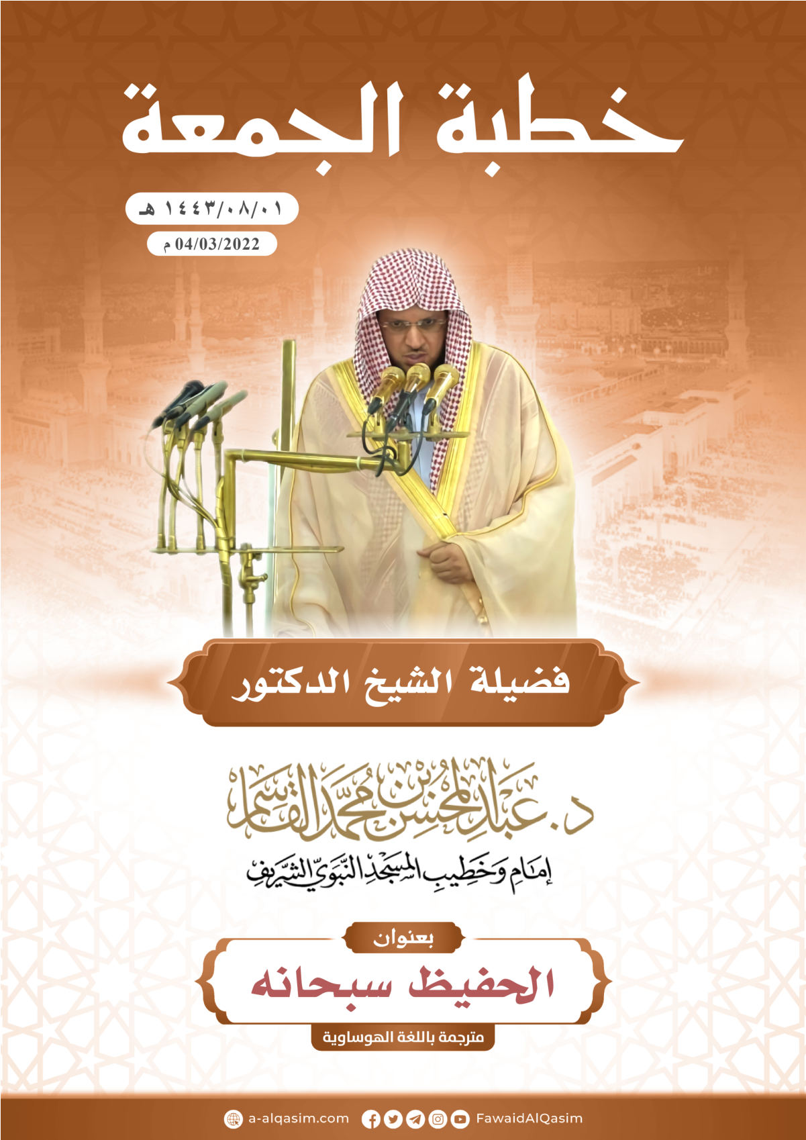

(?) An gabãtar da ita ranar Juma’a a Masallacin Annabi, bisa tarihin: ɗaya ga watan takwas, shekara ta dubu ɗaya da ɗari huɗu, da arba'in da uku, bayan Hijira; 1/8/1443هـ, wanda yayi dai-dai da: 4/3/2022م.

