How Dr. Benoist accepted Islam?
(English)
كيف أسلم د/ بينويست
( إنجليزي )

http://www.islamland.com
I am a doctor and I come from a fanatically Catholic family. Yet my vocational choice, medicine, provided me a career in positive, experimental, and natural sciences, which in turn caused me to develop a growing hatred against Christianity.
With respect to religion, I was at complete loggerheads with the other members of my family. Yes, there was a great Creator, and I believed in Him, i.e. Allahu ta’ala. Yet the absurdities concocted by Christians, especially by Catholics, various mysterious gods, sons, holy ghosts, the preposterous fibs fabricated for the purpose of proving that Issa a.s. is the son of God, a myriad of other superstitions, ceremonies and rites pushed me away from Christianity, instead of attracting me towards it.
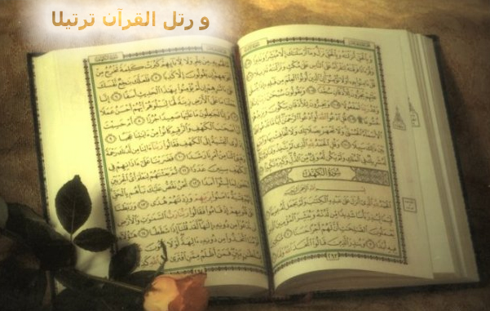
Because I held the belief in one God, I would never accept trinity, nor would I by any means recognize Issa a.s. as the son of God. That means to say that, long before knowing of Islam, I had already accepted the initial half of the Kalimat-ul-Shahada, i.e. the part that says, "La ilaha il'l'Allah... (There is no God but Allah...)" When I began to study the Islamic religion and read the Ikhlas Sura of Qur'an al-karim, which purported, "Lo; Allahu ta'ala is One. He is not begotten, nor does He beget. There is no being bearing any likeness to Him," I said, "O my Allah. My belief is exactly the same." I felt immense relief. I realized that it was of paramount importance to study Islam more deeply.
And as I studied Islam I saw with admiration that this religion was completely agreeable with my ideas. Islam looked on religious men, and even on prophets 'alaihim-us-salawat', as ordinary people like us; it did not divinize them. Giving a priest authority to forgive people's sins was something which Islam would never accept. The Islamic religion did not contain any superstitions, any irrational rules, or any unintelligible subjects. The Islamic religion was a logical one, exactly as I wanted.
Contrary to the Catholics, it did not smudge human beings with the consequences of the so-called original sin. It enjoined physical and spiritual cleanliness on human beings. Cleanliness, which is an essential principle in medicine, was in Islam a commandment of Allahu ta'ala. Islam commanded to clean oneself before acts of worship, and that was a quality which I had never seen in any other religion.
In some Christian rites, such as Baptism and the Eucharist, people consume the bread and wine offered by the priest in the name of the flesh and blood of Issa a.s., which is intended, so to speak, as a simulated unity with Issa a.s., i.e. with God, [may Allahu ta'ala protect us from holding such beliefs!]. I saw the resemblance between these rites and those of the most primitive heathens, and hated them.
My mind, which had improved under the guidance of positive science, vehemently rejected these puerile rites which did not suit to a true religion. Islam, on the other hand, did not accommodate any of those things. There was only truth, love, and cleanliness in Islam.
Eventually, I made up my mind. I visited my Muslim friends and asked them what I should do to become a Muslim. They taught me the (statement called) Kalimat-ul-Shahada, how to say it and what it meant. As I have mentioned earlier, before becoming a Muslim, I had accepted its first half, i.e. the part that meant, "There is no God but Allah,..." It was not difficult, therefore, to accept the remaining part, which said: "... and Muhammad a.s. is His (born slave and) Messenger." I was now studying momentous books written about the Islamic religion.
When I read one of them, namely, 'Le Phénomène Coranique', a very lovely book prepared by Malak Bannabi, I saw with amazement and admiration what a tremendous book Qur'an al-karim was. The facts written in that book of Allah which was revealed fourteen centuries before now are in precise conformance with the results of today's scientific and technological research. Both from scientific and technological points of view and with respect to sociological activities, the Qur'an al-karim is a guide book not only today, but also forever.
On the twentieth day of February, 1953, I went to the Paris mosque and accepted Islam officially in the presence of Mufti Effendi and the witnesses, and I was given the name Ali Salman.
I love this new religion of mine. I am very happy and I emphasize the firmness of my belief in Islam by frequently saying the (statement called) Kalimat-ul-Shahada and pondering over its meaning.

