Qgk akc[hjajsRy ]Ëik; ihju cÙ\ln[ LisRy ijCIlc;. ijCIlc; Cgjulus(jH alYfsa egShld\[ ]sflglxk; gÊs/mkduk=o. Lfksdl![ fs' Ql Sgl :xkdxk; ijCIlc; eAjS)!f[ ijCkÓDkG:rj sRyuk; fjgkck'\jsRyuk; Lmjc[Flr\jhln[. L *jsruk= ijCIlc; sdMj/mk\fjr[ SC<; sv$k' cHdG+*X)[ alYfsa rlsx egShld\[ YefjEh; h>j)kduk=o. cfUijCIlcj fsRy wJijf\jH rjG ^r[Paluk; LyjÉjgjS)! vjh YePlrs/M dlgU* sx c;~r[Pj&[ cKOpj LSy~Uujsh afdlgUidk/[ ekys/mkij&jMk= SvlpU*xk; LfjsRy af ijPjdxk aldk'k flsq sdlmk)k'f[.
SvlpU;î agj&[ SeluiSglSml, c[Fh\j#l\iSglSml Tc[fjzlc éc|lu;Sfmkdê rm\k'f[ dkE[y[ : Snl?
K\g;î Lsf, agj&[ aNayÉiSglmk;, c[Fh\j#l \iSglmk; c|lu; Sfmk'f[ LijCIlc; fs'uln[, L*jsr sv$k'iG Tc[hlajsRy i{\\jH rj'[ eky\[ Seldkduk; sv$k'fln[. sfxji[î L#l|k eyuk'kîÞi#irk; L#l|kSilsml/; aËki# sspiS\ uk; ijxj&kYelGÒj)k' eÊ;- Lfj'[ LisRy e) H ulsflgk Yealnik; T# fs'- LisRy ijvlgn LisRy gÊjflijsRy Lmk)H si&k fs'ulujgj )k;. cfU rjS<PjdX ijwu; Yelej)kduj#, fJG&ß éLH akL[ajroRî117ê. iJ!k; L#l|k eyuk'kî ÞL*j sruk=irldk'k rj*xksm gÊjflilu L#l|k. Li'ldk'k :PjefU;. Lirkekysa :Sglm[ rj*X YelGÒj)k'kSil LiG Qgk TO\/q)kgkijsRy elm Selhk; Kmas/mk\k'j#ß éElfIjGî13ê. L#l|k eyuk 'kî Þrj*X LiSglm[ YelGÒj)k'eÊ; LiG rj* xksm YelGÒr SdX)kduj#. LiG SdMlhk; rj* X)iG K\g; rHdkduj#. KujGs\qkS'HejsRy rlxjhldsM rj*X Lisg e(lxjdxl)jufjsr Li G rjS<Pj)k'fkaln[. coÊ[aw[Blrak=isr éL#l |ksiêS/lsh rjr)[ijig; fglrlgkaj#ß éElfIjGî 14ê
SvlpU;î ak|+p[ r~jéêsuSelshuk= YeilvdØl gksmSul, aËk cIlhj|J*xksmSul D~G cÕGCr; hÊU; si&[sdl![ ulYf ekys/mH Tc[hlajH Lrk iprJualSnl?
K\g;î YeilvdØlgksmSul, cIlhj|J*xkSmSul aËk= igkSmSul D~G cÕGCr; hÊU; si&[sdl![ ulYf ekys/mH Tc[hlajH LrkiprJua#. L*jsruk= ulYf ~jp[L\ldk'k. dlgn; YeilvdRéê eyuk 'kî éeknU; :Yz|j&[sdl![ ao'[ e=jdxjSh)[ alYf Sa ulYf ekys/mkilR elsml=o, a)ujsh e=j, TO e=jéac[wjpk'~ijê Ehc[fJrjsh ac[wjpkH LD[cê YeilvdR iJ!k; eyuk'kî Þr+ksm af\jsRy dlgU \jH T#l\f[ :sg(jhk; svu[flH Lf[ f=s/Sm !fldk'kß. t'lH Qgk*j ulYf ekys/mlsfuk= D~G cÕGCr; Tc[hlajH ck'\ldk'k. dlgn; L#l|kijsRy YeilvdR eyuk'kî Þrj*X D~G cÕGCj)kd dlgn; Lf[ rj*sx egShlds\ QlG +j/j)k'fln[ß éakc[hj;ê.
1
SvlpU;î aNayÉ[ SelujMk= QOhjul)sx sdl![
c|lu; Sfmk'fjsRyuk;, D~ykdsx fIilE[ sv$k 'fjsRyuk;, Lijsmuk= d#kdX sdlS!l, aËkic[ fk)X sdlS!l LrkYz|; Sfmk'fjsRyuk;, D~yk dX)[ fnhk!lilR Si!j sdMjmak!l)k'fj sRyuk; Tc[hlajd ijPj tÔln[?
K\g;î D~ylxjSxlmk;, aNayÉ[Selu QOhjul)Sxl mk; c|lu; Sfmk'fk;, LiG)[ Si!j SrG& iqjel mkdX rm\k'fk;, Lisg L#l|kijSh)k= alGzal )k'fk;, c|lu; Sfmk'fk; Tc[hlajd i{\\jH rj'k; eky\[ Seldk' ihju CjG)ldk'k. alYfa# TO ijCIlc\jH fs' agj)kduk; svu[flH LiR rgd\jH rjfU ilcjukalujgj)k;. t'lH D~yjsr fIilE[ sv$k'fk;, Lfjr[ fnhjr[ Si!j sdMjmak !l)k'fk; ~jp[L\k;, : D~yjH dm)k'isg :glPj)kilrk= Qgk alGzikalufjrlH L*jsr sv$H rj<jÓikaln[, Trj TO goe\jH sv$k'f[ LfjH LÔU ijYCa; sv$k'iG Lfjhosm rak)[ rØdX rHdkduk;, fjØdsx fmk)kduk; sv$ksa ' KS`C\jhosmulsn(jH Lf[[ CjG)jShs)\j)k duk; sv$k;.
SvlpU;î wly*xjSh)k;, aNayÉiG)k; Si!j ~hj uyk)k'fjsRyuk;, Lfjhosm rØ, fjØdX YefJÊj )k'fjsRyuk; ijPjsuÔldk'k?
K\g;î :sg(jhk; wly*xjSh)k;, aNayÉ[ Selu iG)k; Si!j Lyk\lH Lf[ ihju CjG)ln[, alYfa# LiR Cej)s/Mirkaldk'k. dlgn;, Lhj éê YeilvdRéêujH rj'[ K`gj)k'kî ÞL#l|ki#l \iG)[ Lyk\isg L#l|k Cej&jgj)k'k… |pJc[ê
SvlpU;î L#l|kijsRy QOhjul)xksm D~ykdxjSØH e=jdX rjG+j)k'fk;, D~ykdxj#l\ e=jdX K!lujgjS) LSf c[Fh\k= D~yk= e=jdxjH rac[dgj)k'fk; Tc[hlajH LrkiprJualSnl?
K\g;î D~ykdxjSØH e=jdX rjG+j)kilrk;, D~ yk= e=jdxjH rac[dgj)kilrk; elmj#. dlgn;î Ye ilvdRéê eyuk'kî ÞYeilvdØlgksm D~ykdsx e =jdxl)ju wofssYdc[fisg L#l|k Cej&jgj)k 'kß é~kDlgj,akc[hj;ê. akc[hj; K`gj)k' |pJcjH rak )[ dlnl;, YeilvdRéê eyuk'kî ÞLyjukdî rj*xk sm akRzlajdX Ligksm YeilvdØlgksmuk;, cp[i{ \gksmuk; D~ykdsx e=jdxl)jujgk'k, Lyjukd. rj*X D~ykdsx e=jdxl)gkf[, Blrf[ rj*X)[ ijSglPj&jgj)k'kß. wl~jGéêijHrj'[ akc[hj; K`gj)k 'kî ÞYeilvdRrj'[î ÞYeilvd fjgkSarj D~ykdX dk+luajmk'fjsruk;, LfjSØH Tgj)k'fjsruk;, LfjSØH tmk/k!l)k'fjsruk; ijSglPj&jgj)k'k
2
SvlpU;î SwlHcUØlgksmumk\k;, dn)[ SrlM)lgksm umk\k; Seldk'f[ LrkiprJualSnl?
K\g;î SwlHcUØlgksmumk\k;, dn)[ SrlM)lgksm umk\k;, algn)lgksmumk\k;, alulwlh)lgksmumk \k; Seldkilrk;, LiG eyuk'f[ ijCIcj)kilrk; elmj#. dlgn; YeilvdfjgkSarj eyuk'kîÞ:sg(jhk; Qgk dn)[ SrlM)lgsRyumk\[ Seluj tsÔ(jhk; Svlpj&lH LisRy rlHef[ pjics\ rac[ dlg; cIJdgj)kduj#ß éakc[hj;ê. dn)[ SrlM)lgjH >lij Yeivj)ksa'[ eyuk'igk;, ilpj)k'igksa#l; KX s/mk'fln[. YeilvdRéê eyuk'kî é:sg(jhk; Qgk SwlHcUsRyumk\[ Seluj i#fk; Svlpj)kduk;, L iR eyuk'f[ ijCIcj)kduk; svu[flH LiR ak| +p[r~j)[ Ty)s/MfjH LijCIcj&jgj)k'kß éL ~opliop[, rclT, fjGajpj, T~[rk alwê.

SvlpU;î L#l|k L#l\igksm SegjH cfU; sv$H LrkiprJualSnl?
K\g;î L#l|ki#l\isgsdl![ cfU; sv$H Lrk iprJua#. dlgn; YeilvdfjgkSarj eyuk'kî ÞLyj ukd, rj*xksm ejfl)sx ejmj&[sdl![ cfU; sv$H L#l|k rjSglPj&jgj)k'k, :sg(jhk; cfU; sv$kd ulsn(jH L#l|kijsRy SegjH cfU; sv$sM, L fs#(jH rjC~[prlujgj)sMß é~kDlgj, akc[hj;. asËl gk yjS/lGMjhk=f[ TYedlgaln[. L~o|kssyyujH rj'[ rjSipr;î Þrj*X rj*xksm ejfl)sxSul, al fl)sxSul ejmj&[sdl![ cfU; sv$gkf[ cfUilØl glujsdl!#lsf L#l|kijsRy Segjhk; cfU; sv $gkf[ß éL~opliop[, rclTê. YeilvdRéê eyuk'kî Þ:sg(jhk; L#l|ki#l\isgsdl![ cfU; svu[fl H LiR LijCIcj&k, Lfs#(jH CjG)[ svu[fkß éCgjulu crpjhosm L~opliopk;,fjGajpjuk; K`gj&f[ê.

SvlpU;î D~yjSØH DkG:rjd ivr*xk;, agj&ulxk sm Segk;, fj$fjuk; tqkfjsi)kilR elmkS!l?
K\g;î T*sr tqkfjsi)kilR elmj#. dlgn;î Yeilvd fjgkSarjujH rj'[ wl~jGéê K`gj)k' |pJ cjH rak)[ dlnl;î ÞYeilvd fjgkSarj D~G si= eoCk'fk;, LfjSØH Tgj)k'fk;, tmk/k!l)k'fk; rjSglPj&jgj)k'kß éakc[hj;, Cgjulu crpjhosm fjGaj pjuk;, rclTuk; éLfjSØH tqkfk'fk;ê t'kdomj doMjSvG\jMk![ê. T~[rk ~lc[éyê.
3
SvlpU;î a$j\jsr ayalmjufjr[ SC<; D~yj'gjdjH si&[ DkG:R elglun; sv$k'fjsRyuk;, agj& iJ MjH agj&ulSxlmk= LrkdÙ dlgn\lH DkG:R elglun; sv$k'isg ilmds)mk\[ elglun; sv $j/j)k'fjsRyuk; ijPj tÔ[?
K\g;î en[}jfØlgksm Ye~halu L>jYelu Yedlg; ayalmjufjr[ SC<; Lijsm si&[sdl![ DkG:R el glun; sv$k'f[ ~jp[L\ln[, dlgn; TO cYÙpl u; YeilvdsRy dlh\k!lujgk'j#, YeilvdR L *jsr sv$kilR dHej)kdSul, sv$kdSul svu[ fjMj#. t'lH YeilvdrjH rj'[ i'jMk=f[î a$\j sr ayalmjulH Lijsmrj'[ sdl![ LS`|; eyukal ujgk'kî Þrj*X rj*xksm cS|lpgr[ Si!j ele Salvr; Sfmkduk;, c[Fjgf)[ Si!j YelGÒj)kuk; sv$kd, dlgn; LS`|; TS/lX Svlpj)s/mk'fl n[ß TO cÕG>\jH DkG:R elglun; r#fk;, Cy TH seMfkalsn(jH YeilvdR Lijsmsi&[ fsRy cao|S\lmf[ dHej)kalujgk'k. Lf[Selshfs' agj& iJMjHsi&[ a$\jsRy :f[alijsRy SaH DkG :R elglun; sv$k'fjrk; Tc[hlajH Qgk Lmjc[ Flrikaj#. chEkcIlhj|J*xjH rj'[ :gk; TYedl g; svu[fjSMuj#. Trj Qgk akc[hjaj'[ i# ije\kd xk; ~lPj&lH LiR LfjH Êaj)kduk;, L#l|kij H rj'k= YefjEh; YefJÊj)kduk;, Êalhk)sx Selsh YelGÒj)kduk; sv$kd.
( إِنَّا لِلَّهِ وَإِنَّا إِلَيْهِ رَاجِعُونَ) اللَّهُمَّ أْجُرْنِي فِي مُصِيبَتِي وَأَخْلِفْ لِي خَيْرًا مِنْهَا)
LGÒ;î B*X L#l|kijsRy LPJr\jhldk'k, L irjSh)[ fs' amS*!igkaldk'k, L#l|ksi, trj)[ ~lPj&jMk= ije\jH YefjEh; rHSdnSa, LfjSr)X r#fjsr trj)[ edg; rHSdnSaê L f[Selsh a$\jr[ vkËkajgk'[ DkG:R elglun; sv $k'fk;, Lijsm >Ên; ijfgn; sv$k'fk; Tf[ Selhk=fk; ~jp[L\ln[. éT~[rk KssFaJRéyê

SvlpU;î YeilvdsRySul aËki#igksmSul wØpjr\j Srlmrk~r[Pj&[ Lyk\ al;cSal, YeSfUdaluj K!l )ju >ÊnSal dqj)H LrkiprJualSnl?
K\g;î Yeilvd wØpjrS\lmrk~r[PjS&l, QOhjul) X)[ Si!jSul Lisg a|fIiHdgj&[ sdl![ Lyk \f[ L#l|ki#l\isg KS`Cj&[ sdl![ Lyk\f[ Selshuln[, Lf[ CjG)kaldk'k. :ufjrlH LfjH rj'[ LHe;Selhk; >Êj)kilR elmj#. YeilvdrjH rj'[ i'jMk![î ÞL#l|ki#l\iG)[ Si!j Lyk\ isg L#l|k Cej&jgj)k'kß.
SvlpU;î uFlGÒ ijCIlcjdX)[ ~jp[L\kdxk;, Dkyl
4
El\kdxk; sv$k'iG)[Si!j a$\[ rac[dgj)kil rk;, Ligksm wrlcujH es(mk)kilrk; elmkS!l?
K\g;î CjG)jShs)\j)k', L#l|ki#l\iSglmk; agj&[ SeluiSglmk;, wj'kdSxlmk;, ah)kdSxlm; aËk; c|lu; Sfmkd, Tc[fjzlcrm\kd Selhk=f[sv$k 'igksm wrlcujH es(mk)kilSrl, LiG)[ Si!j rac[dgj)kilSrl elmj#. t'lH CjG)jShs)\j )l\ CjG)jsRy ivr*sxl'kaj#l\ goe\jH Ye ilvd wØpjralSZ<j)kd, Tc[ylTsRyuk;, ajL[yl wjsRyuk; glYfjujH :SZl<; c;Zmj/j)kd Selsh uk= ~jp[L\kdX sv$k' elejdxksm wrlcujH es(mk)kduk;, LiG)[Si!j rac[dgj)kduk; sv $l;, Lf[Selsh fO|Jpk= elejdX)[ Si!j rl; eleSalvr; rm\k'f[Selsh LiG)k; sv$lik' fln[. dlgn; L#l|keyuk'kî ÞfS'lm[ e([ SvG) s/mkd t'f[ L#l|k selyk)kduj#, fJG&. Lsfl qj&k=f[ LirkS`Cj)k'iG)[ LiR selyk\[ sdlmk)k'fldk'kß érjclL[î 116ê

SvlpU;î L#l|k :dlC\k;, >oajujhk; t#l c[Fh \k; Ks!'k eyuk'igksm ej'jHrj'[ rac[dgj)k ilR elmkS!l?
K\g;î uFlGÒ L|[hkck'fj iH walL\jsRy ijCIlc Yedlg;, L#l|k K'frk; t#l c{<[mjdX )k;L/ky\[ eplGÒlfJf Shld\kaldk'k. LisRy a|fI\jr[ Sulwj)k' goe\jH cj;|lcr\jH Ke ij<[Arldk'k L#l|k. ijCkÓDkG:rjH T*srul n[ eAj/j)k'f[. L#l|k eyuk'kîÞL#l|k cj;|lc r\jH Keij<[mrldk'kß ÞLiR K'frk;, a|lrkal dk'kß éLH~Dyî255ê. L#l|k eyuk'kî ÞLiR f sRy plcØlgksmSaH egalPjdlgak=irldk'kß éLR :;î 16ê. TOclr~jsu c;~r[Pj&[ eyuk'kî ÞesÊ, LS`|s\ L#l|kLirjSh)[ KuG\jß LiR K' frk;, Yeflejukaldk'k. Lirldk'k :dlC\[ ssp ialujMk=irk;, >oajujH sspialujMk=irk;. L#l|k coy\[ ckDkykEjH eyÉf[Selsh. ÞLirldk'k : dlC\[ sspialujMk=irk;, >oajujH sspialujMk= irk;ß éckDkykE[î84ê. t'lH L#l|kijsRy Lyji[ fsRy c{<[mjdSxlsml/; tS/lqk; K!lujgj)k;. L#l|keyuk'kî Þrj*X tijsmulujgk'lhk; LiR rj*Sxlsml/ak!lujgj)k;ß :sg(jhk; L#l|kijsRy c\Sulsm >oajujhks!'[ ijCIcj)kdulsn(jH L f[ DkG:rjrk;, ck'\jrk;, Tw[alTrk; tfjgln[. :sg(jhk; Lw[Bf sdl!ln[ T*sr ijCIcj)k' sf(jH Li'[ ijCpJdgj&[ sdlmk)kd. Trj ijCpJd gj&[ sdlmk\fjr[ SC<ik; LyjÉ[sdl![ : ijCIl c\jH Ky&[ rjH)kdulsn(jH LiRLijCIlcjul dk'k. LisRy ej'jhk= rac[dlg; Cgjulikduj#.
5

المكتب التعاوني للدعوة والإرشاد وتوعية الجاليات بالجبيل
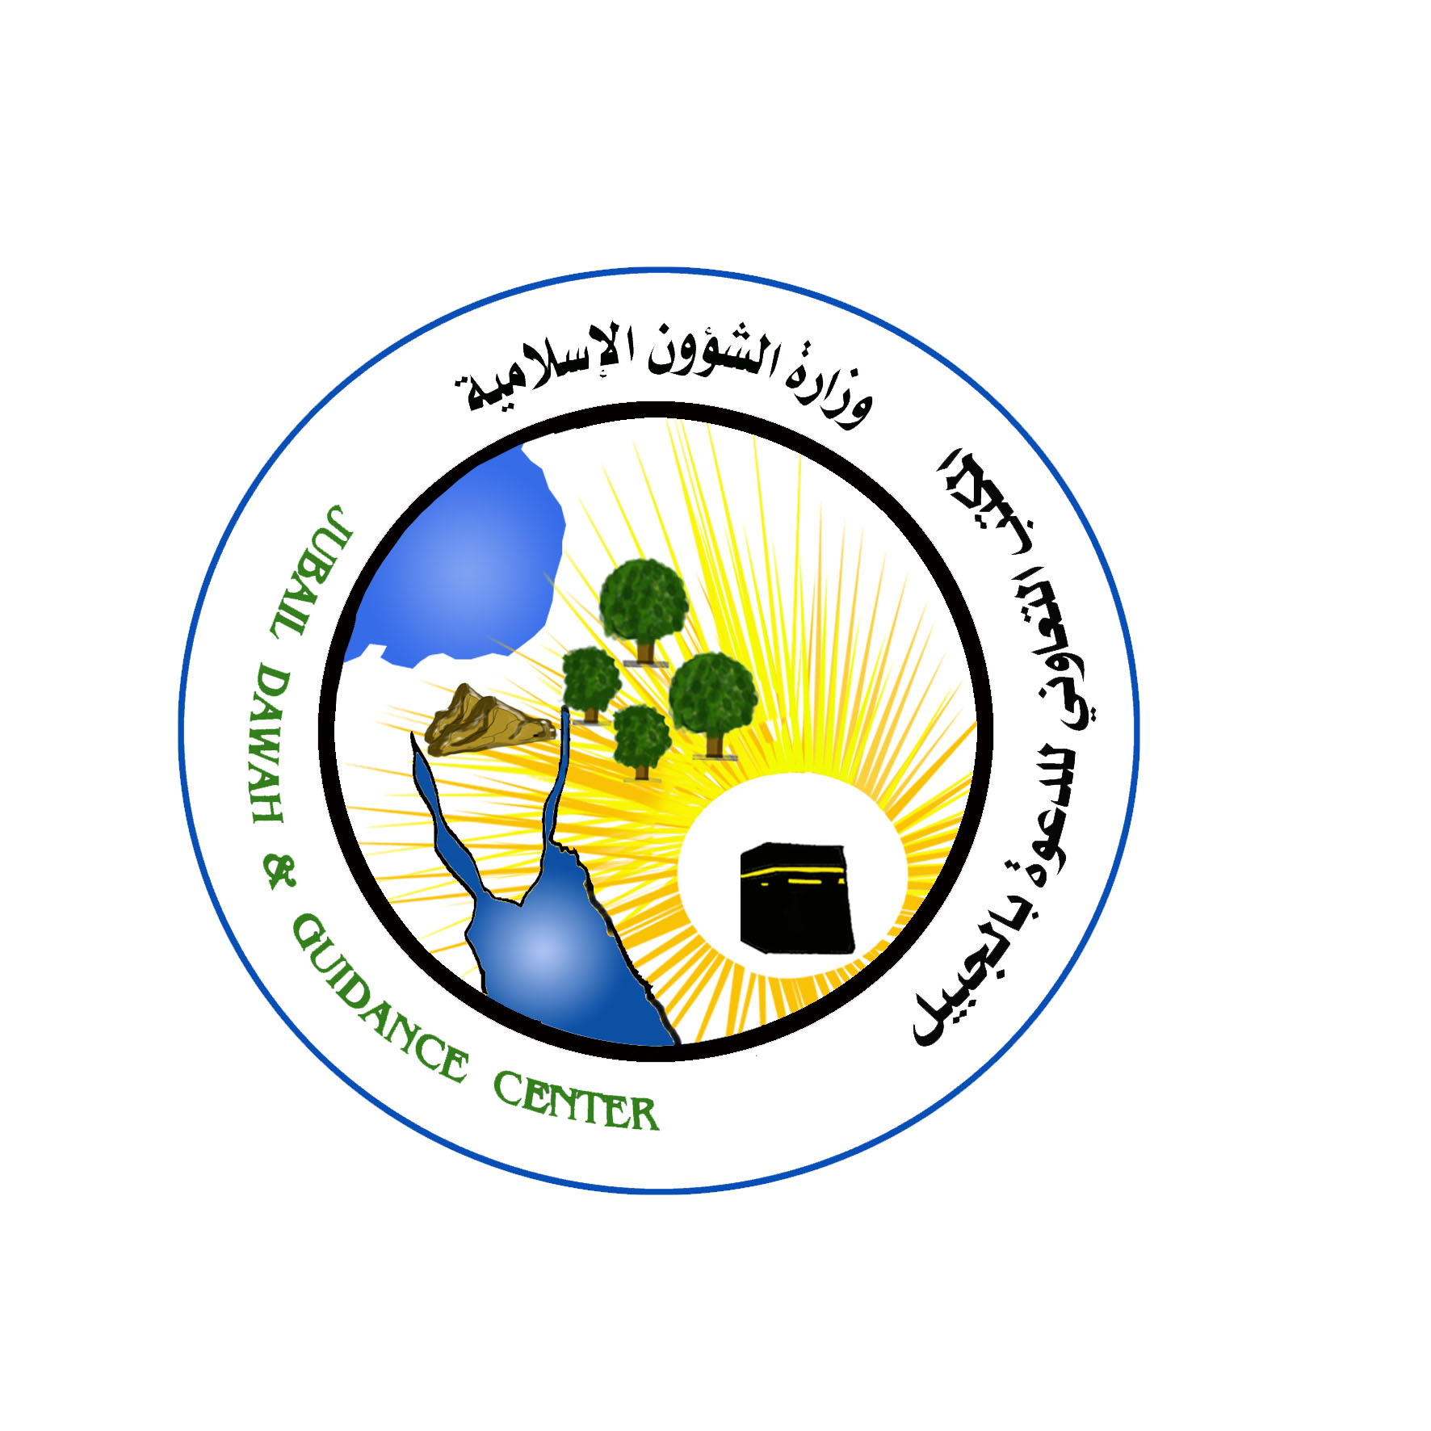
قسم الجاليات

اللجنة الدائمة - المملكة العربية السعودية

ترجمة :
سيد سعفر صادق
الداعية في المكت

salqjalË;î
c$jp[ cL[EG cIlpjD[
wkss~H pL[i scRyG
03- 3625500- 1030

