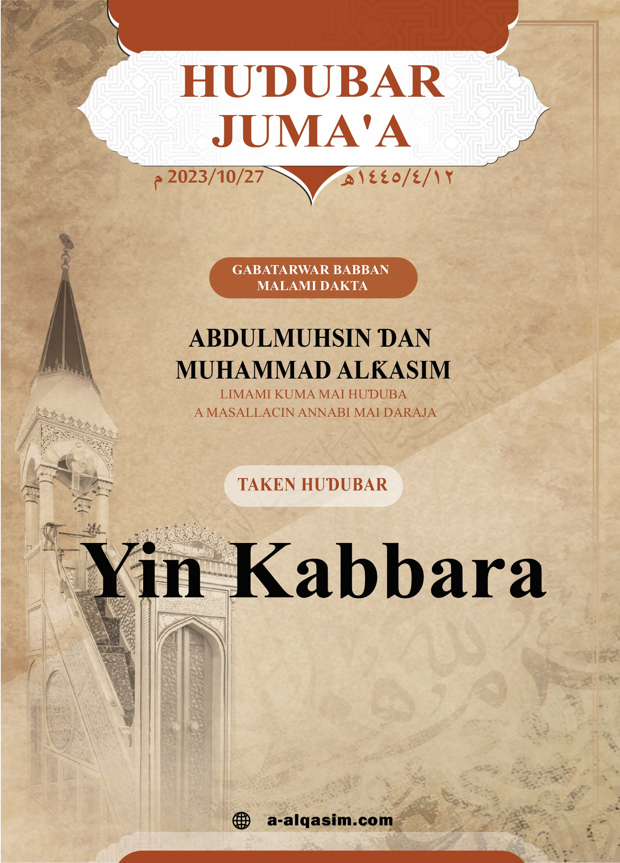

**ل**

**YIN KABBARA\***

Dukkan yabo da godiya sun tabbata ga Allah, muna gode maSa, kuma muna neman taimakonSa, kuma muna neman gafararSa, kuma muna neman tsarin Allah daga sharrin kawunanmu da munanan ayukkanmu. Duk wanda Allah Ya shiryar dashi babu mai ɓatar dashi, kuma duk wanda Ya ɓatar babu mai shiryar dashi. Kuma ina shaidawa babu abin bautawata da gaskiya sai Allah Shi kaɗai baShi da abokin tarayya, kuma ina shaidawa Annabi Muhammad bawanSa ne kuma manzonSa ne, Allah Yayi daɗin yabo a gare shi da iyalansa da   
 sahabbansa da aminci mai yawa.

*An gabatar da wannan huɗubar ranar Juma'a:  
 sha biyu ga watan Rabi'ul Aakhir shekara ta dubu ɗaya   
da ɗari huɗu da arbain da biyar bayan hijra,   
a masallacin Annabi mai daraja.

**Amma ba'adu**:

Kuji tsoron Allah -ya ku bayin Allah- haƙiƙanin tsoro, kuma ku zama a faɗake daShi cikin ɓoyenku da gãnawarku.

**Ayyuhal Muslimuun:**

Haƙiƙanin bauta ga Allah tana tasowa ne daga matuƙar ƙaunarSa tare da matuƙar ƙanƙan da kai, kuma sanin sunayen Allah maɗaukaki da siffofinsa shine tushen ilmomi kuma mafificinSu, shine ilimin da tauhidin Allah Ubangiji tsarki ya tabbata a gareShi da kuma bautarsa suke tsayuwa kansa, kuma mafi girman buƙatar rayuka shine sanin Ubangijinsu kuma maƙagin halittarsu, kuma babu wata hanya zuwa ga hakan sai da sanin siffofinSa da sunayenSa, kuma gwargwadon sanin bawa ga sunayen Allah Maɗaukaki da kuma siffofinSa rabonsa yake kasancewa na daga bautuwa ga Ubangijinsa da samun natsuwa daShi da ƙaunarSa, da darajtaShi da kuma girmamaShi, kuma duk sanda bawa ya ƙara sani acikin sunayen Allah da siffofinSa, imaninsa zai ƙaru, kuma yaƙininsa zai ƙarfafu, kuma Allah Yana ajiye bawa a irin matsayin da bawa ya ajiye Shi a zuciyarsa.

Kuma su sunayen Ubangiji Maɗaukaki dukkansu sunaye ne na yabo, kuma haƙiƙa Allah Wanda tsarki ya tabbata a gare shi ya siffantaSu dacewa mafiya kyawu baki ɗayansu, saboda nuninsu zuwaga siffofi na kamala, kuma na daga sunayenSa tsarki ya tabbata a gareShi «Mai girma» domin Shine mai girma a cikin zatinSa da sunayenSa da kuma siffofinSa, Shine abin siffantawa da girma da jijiji-da-kai.

Kuma duk wanda ya tabbatar da cewa Allah Shine mafi girma sama da dukkan komai; zai girmamaShi matuƙar girmamawa, bazai gabatar da bauta ga wani baicinSa ba, Allah Maɗaukaki Ya ce:

**{ﱜ ﱝ ﱞ ﱟ ﱠ ﱡ ﱢ ﱣ ﱤ ﱥ** **ﱦ ﱧ ﱨ ﱩ ﱪ ﱫ}**

«Wannan fa dõmin lallai Allah Shĩ ne Gaskiya kuma abin da suke kira wanda bã Shi ba shi ne ƙaryã kuma lallai Allah Shĩ ne Maɗaukaki Mai girma». [Luƙman: 30].

Kuma su halittu babu mai ƙidaye adadinsu, kuma babu mai riskar ilmominsu, fakakkunsu da halartattunsu, kuma babu mai kewayewa da lamarinsu sai Mai girma tsarki ya tabbata a gareShi, Allah Maɗaukaki Ya ce:

**{ﱻ ﱼ ﱽ ﱾ ﱿ}**

«Shi ne Masanin fake da bayyane Mai girma Maɗaukaki». [Ar-ra'ad: 9], kuma Shi Allah Maɗaukaki abin siffantawa ne da magana, kuma maganarSa abun siffantawa ce da daraja da girma, Annabi yabo da amincin Allah su tabbata a gareShi ya ce:

«**Idan Allah Ya zartar da wani abu a cikin sama,** -wato: Ya bada umurnin da yaga dama- **mala'iku zasu buga fukafukansu domin ƙanƙan da kai** –wato: masu ƙanƙan da kai- **ga maganarSa, kamar shi sarƙa ce a kan mulmulallan dutse, to kuma idan aka cire firgici daga zukatansu, sai su ce**: -wato: idan firgici da tsoro ya gushe daga garesu, sai sashen mala'iku sucema sashe- **Mai Ubangijinku Yace? Sai suce abida Ya ce shine: Gaskiya, kuma Shine Maɗaukaki mai girma**». (Bukhari ya ruwaito shi).

Kuma Shi Ubangijinmu yana da Isa da iko, Mai hukunci ne cikin halittunSa, Mai adalci ne tsakaninsu:

**{****ﲌ ﲍ ﲎ ﲏ}**

«To shi hukunci yana ga Allah Maɗaukaki Mai girma ne». [Gafir: 12].

Kuma Allah Ya umurci bayinSa su girmamaShi matuƙar girmamawa, da tsarkake Shi daga dukkan tawaya da aibi da aka jingina zuwa gareshi, Allah Maɗaukaki Ya ce:

**{ﲖ ﲗ ﲘ ﲙ ﲚ ﲛ ﲜ ﲝ ﲞ ﲟ ﲠ ﲡ ﲢ ﲣ ﲤ ﲥ ﲦ ﲧ ﲨﲩ   
ﲪ ﲫ}**

«Kuma ka ce "Gõdiyã ta tabbata ga Allah Wanda Bai riƙi ɗã ba kuma abõkin tãrayya bai kasance a gare Shi ba a cikin mulkinSa kuma wani masõyi sabõda ƙasƙantuwarSa bai kasance a gare Shi ba" Kuma ka girmama Shi girmamãwa». [al-isra'u: 111].

Kuma dukkan ibadun halittun sammai da ƙasa manufarsu shine kambama Shi da girmama Shi, da darajta Shi da kuma karrama Shi, don hakane Yin Kabbara ya zama wani take ne na manyan ibadu, Yin kabbara a cikin sallah ƙanƙan da kai ne da karaya a gaban Isar Allah da girmanSa, domin yin kabbarorin acikin sallah a tsawon yini -tun daga kiran sallah zuwa kammala zikirorin cikin salloli biyar, da kuma sallolin nafilar dake tare dasu- kabbarori ɗari uku da saba'in da biyar ne, Shaikhul Islam -Allah Ya jiƙansa- ya ce: «cikin faɗinsa: Allahu Akbar: akwai tabbatar da girmanSa, domin ji da isa ya ƙunshi girma, sai dai ji da isan yafi kamala»

Kuma shi aikin hajji na daga cikin ayukkan addini bayyanannu, takensa shine tauhidi, da girmama Allah da yin kabbara a kan dutsen Safa da Marwa, da kuma lokacin jifan jamarat .

Kuma mafi girman ranaku a wajen Allah sune: kwanaki goman Zhul-hijjah, kuma na daga mafi soyuwar aiki zuwa gare Shi girmamaShi da yin kabbara tsarki ya tabbata a gareShi, Annabi yabo da amincin Allah su tabbata a gare shi ya ce:

«**Babu wasu kwanika da suka fi girma a wajen Allah, kuma babu wanda aiki cikinsu suka fi soyuwa gareShi sama da waɗannan kwanika goman; to ku yawaita hailala, da kabbara, da hamdala a cikinsu**». [Ahmad ya ruwaito shi].

Kuma yin kabbara Sunnah ne a lokacin abubuwan na farin ciki da kuma murna, kamar idi guda biyu, da kuma yayin abubuwa murna da jin albishiri, Annabi yabo da amincin Allah su tabbata a gare shi ya ce: «**Ina fatan ku kasance rabin mutanen Aljannah**, Abu Sa'id Al-khudiri ya ce; sai mukayi kabbara». [Bukhari ya ruwaito shi], kuma ana girmama Allah da yin kabbara yayin ganin wata aya daga cikin ayoyinSa, kamar kisfewa, da kuma yayin mamaki da ma duk wani al'amari mai bantsoro; wasu mutane sun nemi Annabi yabo da amincin Allah da ya sanya masu wata bishiya da zasu riƙa neman albarkarta, sai yace: «**Allahu Akbar! (Allah Shine Mafi girma!), wannan kamar yadda banu Isra'el suka ce ne: {Ka sanya mana wani abin bauta kamar yadda suke da abin bauta}**». [An-nasa'i ya ruwaito].

Kuma farar da tafiya damuwa da ɓacin rai da kuma tsoro suna iya kasancewa tare da ita, kuma girmama Allah da kabbara shine abokin hirar matafiyi da kuma natsuwar mai jin firgici; «Annabi yabo da amincin Allah su tabbata a gare shi ya kasance idan ya dai-daita kan raƙuminsa yana mai fita zuwa wata tafiya, yana yin kabbara sau uku». [Muslim ya ruwaito shi], kuma shi yin kabbara abin shar'antawa ne yayin ganin wani abu da yake da wani nau'in girma cikin halittu kamar wurare masu tudu, Jabir -Allah Ya yarda dashi- ya ce: Mun kasance idan muka hau tudu muna yin kabbara». [Bukhari ya ruwaito shi], kuma idan ya hau wani tudu na ƙasa yana kabbara.

Kuma musulmi yana cike wininsa da kabbara, idan kuma ya koma zuwa ga makwancinsa yana yin tasbihi da hamdala ga UbangijinSa sau talatin da uku, kuma yayi kabbara gare Shi sau talatin da huɗu.

Kuma ita kabbara an shar'anta ta a wurare manya, da kuma bigire masu girma, ita shiriya ni'ima ce mai girma tana cancantar godiya, kuma yana daga cikin godiya dominta, yin kabbara ga Allah kan shiryarwa da nunarwa zuwa ga ayukkan addini, da kuma abinda Yake so Ya yarda dashi, Allah Wanda tsarki ya tabbata a gare shi Ya ce:

**{ﲵ ﲶ ﲷ ﲸ ﲹ ﲺ ﲻ ﲼ ﲽ ﲾﲿ   
ﳀ ﳁ ﳂ ﳃ ﳄ ﳅ ﳆ ﳇﳈ}**

«Nãmõminsu ko jinanansau bã za su sãmi Allah ba amma taƙawa daga gare ku tanã sãmun Sa, Kamar haka Ya hõre su sabõda ku dõmin ku girmama Allah sabõda shiriyar da Ya yi maku». [Al-hajj: 37].

Kuma yana daga cikin gode mata, girmama Allah kan tabbatuwa kan shiriya da samun damar gabatar da ibada; Allah Wanda tsarki ya tabbata a gare shi Ya ce:

**{ﲭ ﲮ ﲯ ﲰ ﲱ ﲲ ﲳ ﲴ ﲵ}**

«kuma dõmin ku cika adadin kuma dõmin ku girmama Allah a kan Yã shiryar da ku kuma tsammãninku zã ku gõde». [Al-baƙarah:185], Shaikhul Islam -Allah Ya jiƙansa- ya ce: «An shar'anta yin kabbara kan shiriya da arziki da kuma nasara; saboda waɗannan ukun sune mafiya girman abinda bawa yake nema, kuma itace matattarar maslahohinsa».

Kuma shi «Allahu Akbar» Kalmace mai girma da Allah Yayi umurni da ita; domin IsarSa ta mamaye cikin zukata, Allah Wanda tsarki ya tabbata a gare shi Ya ce:

**{ﲠ ﲡ }**

«Kuma Ubangijinka ka girmama Shi». [Al-muddath-thir: 3], Al-ƙurɗubi Ya ce: «Ana cewa: Lafazi mafi kai matuƙa a wurin larabawa wacce ke da ma'anar girmamawa da darajtawa shine: Allahu Akbar», kuma ita kalma ce ta fiɗira -ɗabi'ar halitta- wacce Allah Ya ɗabi'antar da halittar mutane a kanta, Anas ɗan Malik –Allah Ya yarda da shi- ya ce: «Manzon Allah yabo da amincin Allah su tabbata a gare shi yaji wani mutum yana cewa: Allahu Akbar, Allah Akbar, sai yace: **Yana bisa fiɗira**». (Muslim ya ruwaito shi).

Kuma ladanta mai gwaɓi ne, da kuma ita ne ake samun darajojiji maɗaukaka, kuma ita tana daga cikin kalmomi da Allah Yake sonsu, Annabi -yabo da amincin Allah su tabbata a gare shi- ya ce: «**Mafi soyuwar magana a wurin Allah sune: Subhanallah, walhamdu-lillah, wa la-ilaha illallahu, wallahu akbar**». (Muslim ya ruwaito shi), «kuma dukkan kabbara sadaka ne». (Muslim ya ruwaito shi), kuma shi sadaka ne kan shi mai zikirin, kuma alkairai ne, da kuma ayyukan biyayya, «**kuma dukkan kabbara sadaka ce**» [Muslim ya ruwaito shi], kuma Mala'iku suna kewayewa da fika-fikansu zuwa saman duniya majalisun zikiri da akewa Allah tasbihi da kabbara a cikinsu». [Bukhari da Muslim suka ruwaito shi], kuma da kabbara ne da hamdala da tasbihi ake buɗe ƙofofin sama, Ibnu Umar -Allah Ya yarda da su- ya ce: «A lokacin da muke sallah tare da Manzon Allah -yabo da amincin Allah su tabbata a gare shi- sai wani mutum daga cikin mutane yace: Allahu Akbaru Kabiran, Walhamdu lillahi kathiran, wa subhallah bukratan wa aselan, sai Manzon Allah -yabo da amincin Allah su tabbata a gare shi- ya ce: **waye ya faɗi kalma kaza da kaza**, sai wani mutum cikin mutane yace: nine ya Manzon Allah, sai yace: Nayi mamakinta, An buɗe mata ƙofofin sama». (Muslim ya ruwaito shi), kuma a ranar Ƙiyama tana da nauyi a mizani; Annabi -yabo da amincin Allah su tabbata a gare shi- ya ce: «kai kai! ga abubuwa guda biyar, me ya kaisu nauyi a mizani, La'ilaha illa Allah, wallahu Akbar, wa subhannallahi, wal hamdulillahi, da kuma ɗa na ƙwarai da zai rasu sai mahaifinsa ya nemi ladan rashinsa». (Ahmad ya ruwaito shi).

**Bayan haka, ya ku musulmai**:

Allah Mai girma ne babu wanda ya fishi girma, kuma shi yake da isa da girma a cikin sammai da ƙasa, kuma isarSa abu ne da hankula kan kasa riskar haƙiƙanin ta, ko suranta ta, ko kuma sanin yanayinta, kuma duk abinda ke bijirowa ga ran bayi na girmamawa to Allah Ya fishi girma, «**Allah Zai sanya sammai kan yatsa, ƙassai kan yatsa, bishiyoyi kan yatsa, ruwa da ƙasa a kan yatsa, sauran halittu kan yatsa**». [Bukhari da Muslim suka ruwaito shi], kuma shi mumini yana fakewa ne da Ubangiji Mai girma, kuma yana dogaro daShi, yana miƙa al'amuransa gareShi, kuma yana roƙonSa Shi kaɗai yana ratayuwa daShi.

**Ina neman tsarin Allah daga shaiɗan jefaffe:**

**{ﲵ ﲶ ﲷ ﲸ ﲹ ﲺ ﲻ ﲼ ﲽ ﲾ ﲿ ﳀ ﳁﳂ ﳃ ﳄ ﳅ ﳆ}**

Kuma ba su girmama Allah haƙĩƙanin girmamaSa ba alhali ƙasã dukka damƙarSa ce a Rãnar Ƙiyãma kuma sammai abũbuwan naɗewa ne ga dãmanSa Tsarki ya tabbata a gare Shi kuma Ya ɗaukaka daga barin abin da suke shirki da shi». [Az-zumar: 67].

Allah Ya sanya mana albarka tare daku a cikin Alƙur'ani mai girma…

**HUƊUBA TA BIYU**

Dukkan yabo da godiya sun tabbata ga Allah gameda kyautatawarSa, godiya ta tabbata a gare Shi bisa datarwarSa da kuma ni'imominSa, ina shaidawa babu abin bautawa da gaskiya sai Allah Shi kadai baShi da abokin tarayya ina mai girmama al'amarinSa, kuma ina shaidawa Annabinmu Muhammad bawanSa ne kuma ManzonSa ne, yabo da amincin Allah su tabbata a gare shi da iyalansa da sahabbansa, kuma Yayi daɗin aminci mai ƙaruwa.

**Ayyuhal Muslimuun:**

Babu jin daɗi ga bayi, kuma babu kyautatuwar lamuransu, kuma babu ni'imtuwa, saidai su san Ubangijinsu, kuma Shi kaɗai Ya zamto maƙurar abin nemansu, kuma sanininSa shine sanyin idanuwansu, kuma ji da isa na daga abubuwan da suka keɓanci Ubangijintaka, kuma Allah Yayi alƙawarin azaba ga wanda ya siffantu da shi daga cikin halittu, Annabi -yabo da amincin Allah su tabbata a gare shi- ya ce: «**Buwaya kwarjalle Na ne, kuma ji da isa kuma mayafiNa ne, to duk wanda yake jayyya daNi Zan azabtar dashi**». [Muslim ya ruwaito shi].

Ibnul Ƙayyim -Allah Ya jiƙansa- ya ce: «yayinda ji da isa, yafi girma da yalwa, sai yafi cancantar sunan mayafi», to bawa ya kiyayi jiji dakai a doron ƙasa, da girman kai ga halittu, da kuma nuna masu finƙarfi da zaluntar su, kuma duk wanda aka bashi ƙarfi da ɗaukaka, sai ransa ya kirashi zuwa zalumtar wani mai rauni; mata ce da waninta, to ya tuna lallai Allah Ya fishi girma a zati da matsayi da iko, Allah Maɗaukaki Ya ce:

**{ﱡ ﱢ ﱣ ﱤ ﱥ ﱦﱧ ﱨ ﱩ ﱪ ﱫ ﱬ}**

«kuma idan suka yi maku ɗa'a kada ku nemi wata hanya a kansu, lallai ne Allah Ya kasance Maɗaukaki kuma Mai girma». [Annisaa: 34].

Duk wanda iliminsa ya ƙarfafa na sanin cewa Allah Mai girma ne; tsoransa gare Shi zai ƙaru, kuma zai girmama Shi kuma zai so Shi kuma zai kyautata bautarSa; kuma duk wani girman kai da jiji da kai da riya zasu fita daga zuciyarsa, kuma Allah Ya sanya aljannah ga bayinSa muminai masu ƙanƙan da kai, Allah Wanda tsarki ya tabbata a gare shi Ya ce:

**{ﲷ ﲸ ﲹ ﲺ ﲻ ﲼ ﲽ ﲾ ﲿ ﳀ ﳁ ﳂﳃ   
ﳄ ﳅ}**

«Wancan gidan Lãhira kenan Munã sanya shi ga waɗanda suke bã su nufin ɗaukaka a cikin rãyuwar dũniya kuma bã su son ɓarna Kuma kyakkyawan ƙarshe ga mãsu taƙawa take» [Alƙasas: 83].

Sannan ku sani lallai Allah Ya umurceku da yin salati da sallama ga AnnabinSa...

