
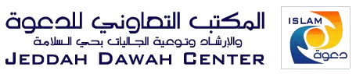
Islamic Studies Curriculum
Specially designed for new Muslims

