



Simplifying the Fundamentals of Creed for the Masses

Simplifying the Fundamentals of Creed for the Masses

Prepared by
Abdullah bin Sulayman Al-Muhanna

Translated by
Omar Jeylani

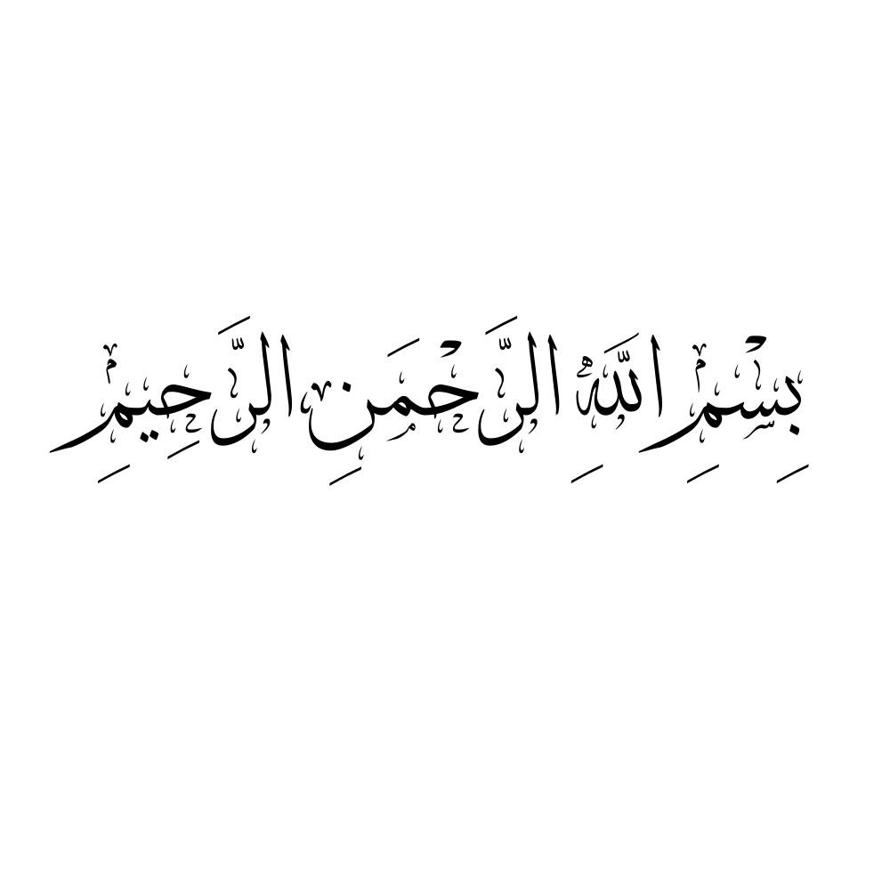

Lesson ( 1 )

If someone asked you: Who is your lord?
Then say: My Lord is Allah
Then if someone asks you: What is the meaning of Lord?
Then say: The One who is worshipped, the Owner, and the Controller (of all affairs).
Then if someone asks you: What is the greatest of His creations that you see?
Then say: The heavens and the Earth
If someone asks you: How do you come to know your Lord?

Then say: By reflecting on His signs and the things He has created.

Lesson ( 2 )

If someone asked you: “What is the greatest creation of Allah that you can see?”
Then say: “The heavens and the earth.”
Then if someone asks you: “How do you know your Lord?”
Then say: “Through His signs and His creations.”
Then if someone asks you: “What does the name ‘Allah’ mean?”
Then say: “It means the One who has divinity and deserves worship from all creation.”
If someone asks you: “For what purpose did Allah create you?”
Then say: “To worship him.”
If someone asks you: “What does it mean to worship Him?”
Then say: “To single Him out in Tawḥīd and to obey Him.”
If someone asks you: “What is the evidence for that?”
Then say: “Allah ﷻ says:
“I did not create the jinn and mankind except to worship Me.’
Surah al-Dhariyat (51:56).”

Lesson ( 3 )

If someone asked you: “What is the first duty Allah placed upon you?”
Then say: “To disbelieve in every false deity (ṭāghūt) and to believe in Allah.”
Then if someone asks you: “What is the evidence for that?”
Then say: “Allah ﷻ says:
‘Whoever disbelieves in Ṭāghūt and believes in Allah has grasped the most trustworthy hand‑hold…’ (Surah al-Baqarah 2:256).”
Then if someone asks you: If someone asks you: “What is the most trustworthy hand‑hold (al‑ʿurwah al‑wuthqā)?”
Then say: “It is the statement ‘Lā ilāha illa Allāh’ (None has the right to be worshipped except Allah).”
If someone asks you: “What does ‘Lā ilāha illa Allāh’ mean?”
Then say: “It is a phrase of negation and affirmation.”
If someone asks you: “What do you negate and what do you affirm?”
Then say: “With ‘Lā ilāha’ I negate all false gods; with ‘illā Allāh’ I affirm worship for Allah alone.”
If someone asks you: “What evidence supports that?”
Then say: “Ibrāhīm عليه السلام said:
‘Indeed, I am disassociated from what you worship - except for the One who created me…’ (Surah al-Zukhruf 43:26‑27).
‘I am disassociated’ is negation; ‘except for the One who created me’ is affirmation.”

Lesson ( 4 )

If someone told you: “Explain fully the phrase ‘Lā ilāha illa Allāh.’”
Then say: “It means: No being is rightfully worshipped except Allah.”
Then if someone asks you: “What is the difference between Tawḥīd of Lordship (rubūbiyyah) and Tawḥīd of Worship (ulūhiyyah)?”
Then say: “Tawḥīd of Lordship concerns Allah’s actions—creating, providing, giving life and death. Tawḥīd of Worship concerns the servant’s acts of worship such as supplication, prayer, fasting, and reliance.”
Then if someone asks you: “What is your religion?”
Then say: “My religion is Islam.”
If someone asks you: “To what does Islam call?”
Then say: “To worship Allah alone and to abandon associating partners with Him.”

Lesson ( 5 )

If someone asked you: “What is the meaning of Islam?”
Then say: “It is surrendering to Allah through Tawḥīd , obeying Him, and dissociating from shirk and its people.”
Then if someone asks you: “What are its pillars?”
Then say: “They are five:
1) Testifying that none is worthy of worship but Allah and that Muhammad is the Messenger of Allah;
2) Establishing prayer;
3) Giving obligatory charity (zakāh);
4) Fasting in Ramadan;
5) Performing ḥajj to the Sacred House for whoever is able.”
Then if someone asks you: “What is īmān (faith)?”
Then say: “It is believing in Allah, His angels, His books, His messengers, the Last Day, and destiny—its good and its bad. These are its six pillars. Whoever holds them is a believer; whoever rejects any one of them is a disbeliever.”

Lesson ( 6 )

If someone asked you: “Who is your Prophet?
Then say: Muhammad, son of ʿAbd‑Allāh, son of ʿAbd al‑Muṭṭalib, of the clan of Hāshim from Quraysh, an Arab from the descendants of Ismāʿīl son of Ibrāhīm عليهما السلام.
He was born in Makkah and emigrated to Madīnah. He lived sixty‑three years: forty before prophethood and twenty‑three as a prophet and messenger.
He was first addressed with the revelation «اقرأ» (“Read!”) and was formally sent with «يا أيها المدثر» (“O you who are wrapped up!”).
Then if someone asks you: Did he die?
Then say: Yes. However, his religion will remain until the Day of Resurrection.

Evidence:
“Indeed, you will die, and indeed, they will die.” (Surah al-Zumar 39:30)
Then if someone asks you: Will the dead be resurrected?
Then say: Yes. Evidence:
“From the earth We created you, to it We shall return you, and from it We shall bring you forth once again.” (Surah Taha 20:55)
Whoever denies resurrection is a disbeliever. Evidence:
“The disbelievers claim they will not be resurrected. Say, ˹O Prophet,˺ “Yes, by my Lord, you will surely be resurrected…
(Surah al-Taghabun 64:7).

Lesson ( 7 )

If someone asked you: “What is the shirk that is the greatest of all sins?
Then say: “Worshipping other than Allah.
Among that:
Calling upon the dead, slaughtering for them, circumambulating their graves, believing they benefit, harm, or manage the universe with Allah, and the like.
Then if someone asks you: “Does Allah forgive shirk as He forgives other sins?”
Then say: “Yes, for the one who repents before death; but whoever dies upon shirk without repentance will remain eternally in the Fire—Allah’s protection is sought.
Then if someone asks you: “ What proof is there for that?”
Then say: Allah, Exalted, says:
“Indeed, Allah does not forgive that partners be associated with Him…” (al‑Nisāʾ 4:48);
i.e for the one who dies upon it.
and He says:
“Whoever associates partners with Allah, Allah has forbidden him Paradise…” (al‑Māʾidah 5:72).

Lesson ( 8 )

If someone asked you: “Were people (originally) upon Tawḥīd , and how did shirk first appear among them?
Then say: Yes, “People remained upon Tawḥīd from Ādam for ten generations—about one thousand years—until shirk appeared among the people of Nūḥ.
How did shirk enter upon them?
It emerged because of exaggeration in love of the righteous—Wadd, Suwāʿ, Yaghūth, Yaʿūq, and Nasr—whom Allah mentioned in Sūrat Nūḥ.
What was that exaggeration?
“When those righteous men died, their folk came to their graves and prayed for them.
Satan suggested: “Make statues of them in your gatherings and name them after them; seeing them will remind you to pray.”
From where is this story?
It is the speech of the Companion Ibn ʿAbbās—may Allah be pleased with him— not from me.”

Lesson ( 9 )

Complete the story for us..
Satan was cunning; he led them gradually under the slogan of “love of the righteous”.
How did he deceive them..?
He first said: “Travelling to the cemetery is taxing; place their images in your assemblies.”
They obeyed. These monuments remained, while knowledge vanished and the scholars died. Then Satan came to them and whispered: ‘Your forefathers used to seek rain through these people, and they were granted it. They used to do such-and-such…’ — so they worshipped them, and thus shirk occurred.
Lā ḥawla wa-lā quwwata illā billāh!! How can people be ignorant of shirk to this level?!
Ask Allah for well-being, learn your religion, and cling to the scholars who uphold pure Tawḥīd .
And then what happened..?
Allah sent His prophet Nūḥ, who called them for nine hundred and fifty years
Alhamdulillah! Perhaps they left off the shirk?
Allah informed us only a few believed, as Allah said:
“…None believed with him except a few.” (Hūd 11:40).

Lesson ( 10 )

From this we learn that exaggeration regarding the righteous is the root of deviation…
Yes, correct.
The Arabs at the time of the Prophet ﷺ did likewise, saying:
“We only worship them to bring us nearer to Allah…” (al‑Zumar 39:3).
For this reason the Prophet ﷺ cautioned against exaggeration concerning the righteous - meaning to raise them to a status that is not theirs - because doing so leads to directing some acts of worship to them.
What did the Prophet say regarding warning about exaggerating the righteous individuals?
The Prophet ﷺ said: “Beware of exaggeration, for those before you were destroyed by exaggeration.” (Musnad Aḥmad).
And he said: “Do not over‑praise me as the Christians over‑praised the son of Mary. I am only a servant; so say: the servant of Allah and His messenger.” (al‑Bukhārī).
Can you mention for us some examples of this forbidden exaggeration?
One of them is: taking their graves as mosques, and about this there is a severe warning, for it is among the greatest causes of shirk.

The Prophet ﷺ said:
May the curse of Allah be upon the Jews and the Christians; they took the graves of their prophets as places of worship.’ (al-Bukhārī).

What does it mean to take graves as mosques?
Taking graves as mosques is of two types:
- Praying at them—even if no mosque is built.
- Building mosques over them and praying therein.

And why was this prohibited?
It was prohibited because this act is a means leading to the worship of the righteous. The ignorant person might assume that the mosque was built specifically to pray for that righteous man.
So Islam blocks the means that lead to shirk?
Yes, that is correct.

Lesson ( 11 )

You have said that taking graves as mosques is among the causes leading to shirk. .
Yes, that’s correct.
Is it permissible to pray in such mosques that have been built upon graves of the righteous?
It is not permissible to pray in such mosques, as has been ruled by the scholars, because these mosques were built upon innovation and disobedience to Allah the Exalted.
They were not founded upon piety and the fear of Allah. Allah the Exalted says:
“A mosque founded on piety from the first day is more worthy for you to stand in…” (Sūrat al-Tawbah 9:108)
So, prayer in mosques that are built over graves is invalid, and whoever has prayed in them must repeat the prayer.
“Subḥānallāh! I never knew this!”
You must know this. And whenever you enter a mosque in a land where mosques built over graves are widespread, you must look and make sure the mosque is free of any grave.
Is there a difference between the grave being in the direction of the qiblah, behind it, or to any other side?
There is no difference in that—all of it is forbidden. Prayer in such a mosque is not valid, even if the grave is behind the qiblah.

May Allah bless you for this clarification. Will you continue mentioning more forms of exaggeration regarding the righteous?
If Allah wills, in the next lesson.

Lesson ( 12 )

You did well in what you mentioned in the previous lesson. Can you now tell us other examples of exaggeration regarding the righteous?
Yes.
Among them: building structures over their graves, decorating them, placing curtains upon them, and constructing domes over them.
The Prophet ﷺ forbade that.
In Ṣaḥīḥ al-Bukhārī, it is narrated from Jābir ibn ʿAbdillāh (may Allah be pleased with him) that:
“The Messenger of Allah ﷺ forbade plastering graves, sitting upon them, and building over them.” (al-Bukhārī)
So nothing should be built over a grave. Rather, it should remain visible and exposed, not plastered.
Similarly, anything that makes the grave conspicuous and draws the attention of the ignorant—such as lighting, draping, or adorning—can cause temptation and instil a sense of fear or awe towards the grave’s occupant.
Like what?
Like placing lights, carpeting the area, perfuming it with incense and the like.
And it is reported from Ibn ʿAbbās (may Allah be pleased with him) that:
“The Messenger of Allah ﷺ cursed women who visit graves and those who take graves as places of worship and light lamps upon them.” (Narrated by the authors of the Sunan)
So, placing lamps and lights upon graves is forbidden, and whoever does so exposes himself to the curse.
Among the worst forms of exaggeration regarding the righteous is circumambulating their graves —we ask Allah for protection.
This is a major evil and an act of shirk with Allah, because it involves offering an act of worship to other than Him.
Circumambulation (ṭawāf) is an act of worship solely for Allah, and it is only to be done around His Sacred House — the Kaʿbah.
Allah the Exalted says:
“...and circumambulate the Ancient House.”
(Sūrat al-Ḥajj 22:29)
There is nothing else in the world that one is to circumambulate seeking closeness to Allah except the noble Kaʿbah.
Lā ḥawla wa-lā quwwata illā billāh. How can this come from a Muslim!?
It happens, sadly, due to the dominance of ignorance and the scarcity of callers to the truth.
We ask Allah for help in fulfilling this responsibility.

Lesson ( 13 )

You did well in what you mentioned in the previous lesson…
Can you now tell us other examples of exaggeration regarding the righteous?
Yes.
Among them is: seeking needs from them, such as asking for the cure of the sick, the return of the missing, intercession with Allah, and similar needs.
And what is the ruling on that?
We ask Allah for safety — this is major shirk (al-shirk al-akbar), which expels a person from the religion of Islam.
Why is it considered shirk?
Because calling upon other than Allah is shirk.
Supplication (duʿāʾ) is an act of worship, and whoever worships anyone other than Allah has committed shirk.
Lā ḥawla wa-lā quwwata illā billāh.
Could you mention some evidences to convince those who fall into this practice?
Yes.
Allah the Exalted says:
But those ˹idols˺ you invoke besides Him do not possess even the skin of a date stone. If you call upon them, they cannot hear your calls. And if they were to hear, they could not respond to you. On the Day of Judgment they will disown your worship ˹of them˺. And no one can inform you ˹O Prophet˺ like the All-Knowledgeable.’
(Sūrat Fāṭir 35:13–14)

In these verses, Allah refers to their supplication as shirk.
And He also says:
“And who is more astray than one who calls upon, besides Allah, those who will not respond to him until the Day of Resurrection—and they are unaware of their calls… and when mankind is gathered, they will be enemies to them and deny their worship.”
(Sūrat al-Aḥqāf 46:5–6)
Allah calls their supplication worship.
And the Prophet ﷺ said: “Supplication is worship.” (Ṣaḥīḥ al-Adab al-Mufrad)
These are clear evidences that calling upon other than Allah is shirk.
But if someone says, “These verses refer to idols, not to the righteous,” what’s the reply?
The reply is that Allah said:
“Those you call upon besides Him cannot help you, nor can they help themselves.”
(Sūrat al-Aʿrāf 7:197)
This verse is general for all that is worshipped besides Allah, because everything besides Him is other than Him.
Also, the people of Jāhiliyyah used to call upon both idols and righteous people.
For example, al-Lāt was a righteous man who used to mix sawīq (a barley food) for pilgrims. When he died, they stayed at his grave in devotion.
Allah says:
“Have you seen al-Lāt, and al-ʿUzzā?”
(Sūrat al-Najm 53:19)
And Allah informed us about the polytheists who said:
“We only worship them so that they may bring us closer to Allah…”
(Sūrat al-Zumar 39:3)
What they meant were the prophets and righteous people.
You’ve done well! These are indeed from the common doubts they present to us—may Allah reward you for exposing them.

Lesson ( 14 )

You did well in what you mentioned in the previous lesson…
But they often present to us a doubt—can you expose it for us?
What is the doubt?
They say: “We know that supplicating to other than Allah is shirk, but what happens at the shrines of saints and righteous people—like when people say: ‘Madad (help), O Ḥusayn! Madad, O Ḥaṣāfi! Madad, O ʿAydarūs!’ and so on—isn’t actually duʿāʾ (supplication); it’s just nidāʾ (a call).”
The answer is that calling (nidāʾ) is supplication (duʿāʾ).
Allah said about Zakariyyā (peace be upon him):
“When he called (nāda) his Lord with a hidden call…”
(Sūrat Maryam 19:3–4)
So Allah referred to his call as duʿāʾ (supplication).
May Allah bless you for this clarification.
But they also say: “This is Tawassul through the saints, and Tawassul is allowed,” citing Allah’s statement:
“Seek the means of nearness (wasīlah) to Him…”
(Sūrat al-Māʾidah 5:35)
What they are doing—calling upon the saints—is not Tawassul.
Rather, it is shirk, by the consensus of the Muslims.

So then, what is the Tawassul that they claim?
We will dedicate the next lesson to the topic of Tawassul, in shā’ Allāh.

Lesson ( 15 )

You promised in the previous lesson to speak about Tawassul—will you fulfil your promise? May Allah reward you with good.
Yes.
We mentioned earlier that what the grave-worshippers do—calling upon the dead and asking them to fulfill needs—is not Tawassul, but major shirk by consensus of the Muslims.
Yet, they deceive the simple-minded by claiming that this is Tawassul through the righteous, and that such Tawassul is permitted.
So we must understand what Tawassul really is so their words don’t deceive us.
Absolutely. The one who is ignorant can be easily misled by the doubts spread by the innovators. You must seek knowledge.
Tawassul is to place between you and Allah a means (wasīlah) that brings you closer to Him.
It is of two types: permissible and prohibited.
✦Permissible Tawassul includes:
1. Tawassul through Allah’s names and attributes
As Allah said:
“And to Allah belong the Most Beautiful Names, so call upon Him by them…”
(Sūrat al-Aʿrāf 7:180)
For example, one says:
“O Most Merciful, have mercy on me. O Forgiving, forgive me. O Provider, provide for me…”
2. Tawassul by confessing one’s sin
As the parents of mankind (Ādam and Ḥawwāʾ) said:
“Our Lord, we have wronged ourselves, and if you do not forgive us and have mercy upon us then we will surely be of the losers.”
(Sūrat al-Aʿrāf 7:23)
3. Tawassul by expressing one’s weakness and need
As Mūsā (peace be upon him) said:
“My Lord, indeed I am, for whatever good You send down to me, in need.”
(Sūrat al-Qaṣaṣ, 28:24)
4. Tawassul through righteous deeds
As in the famous ḥadīth of the three men trapped in the cave, who each called upon Allah by mentioning a good deed they had done sincerely.

✦ Prohibited Tawassul includes:
1. Tawassul through the person of the Prophet ﷺ
For example, saying: “O Allah, I ask You by Your Prophet to forgive me…”
This is not legislated, and is prohibited, because this form of supplication has no basis in the Sunnah.
Whatever lacks proof is rejected.
Imām Abū Ḥanīfah (رحمه الله) said:
“One must not seek Allah through any of His creation.”
As for the ḥadīth of the blind man that some use as evidence—it is weak and cannot be used as proof.
2. Tawassul through the status or honour of the Prophet ﷺ or a righteous man
This too is prohibited and an innovation, as it is not reported in the Sunnah or from the actions of the Companions.
3. Tawassul through the right of so-and-so from the righteous
This is also invalid, for no one has a right over Allah.
4. The worst of the prohibited forms is Tawassul through the dead and idols, like the people of Jāhiliyyah who said:
“We only worship them so they may bring us closer to Allah…”
(Sūrat al-Zumar 39:3)
This is exactly what grave-worshippers do: calling upon the dead and saying they have a high status with Allah.
This is blatant major shirk, as we clarified in full detail in earlier lessons.
So, beware of the distinction between true Tawassul and false claims, so that the doubts of the people of innovation do not deceive you.
May Allah bless you—you explained and clarified excellently.
Can you guide us to some references for further reading?
Yes.
Refer to the book:
“A Clear Principle Regarding Tawassul and Wasilah” (Qāʿidah Jalīlah fī al-Tawassul wal-Wasīlah) by Shaykh al-Islām Ibn Taymiyyah.

Lesson ( 16 )

You did well in explaining the different types of Tawassul, and now I understand that calling upon the dead in the name of Tawassul is in fact a form of prohibited shirk, because it is a supplication directed to other than Allah.
But can you inform me of some of the things people do at the graves of the dead?
Like what?
For example, reciting al-Fātiḥah “upon the soul” of the deceased—without directly calling on him—is that allowed?
This is one of the newly invented innovations (bidʿah).
Visiting graves is legislated in Islam, but the correct practice is to greet the dead and pray for them, as reported in the Sunnah.
As for reciting al-Fātiḥah at graves, this is an innovation and has no basis in the Sunnah.
What about what we see from the Rāfiḍah (Shīʿah) who place large amounts of money at graves?
The Rāfiḍah and the Ṣūfīs have exploited the simple and naive among the people.
They devour their wealth in the name of religion and in the name of vows made to the saints.
In the end, that money simply goes into the pockets of those who guard the graves.
Making vows at graves is in itself prohibited and shirk, because a vow (nadhr) is an act of worship.
Allah says:
“They fulfill their vows…”
(Sūrat al-Insān 76:7)
And the Prophet ﷺ said:
“Whoever vows to obey Allah, let him fulfill it. And whoever vows to disobey Allah, let him not fulfill it.” — al-Bukhārī
So whoever vows for Allah’s sake must fulfil it, but whoever makes a vow to other than Allah—such as those who vow food, animals, or money for the graves of the Prophet’s family or other righteous figures—this is a vow to other than Allah, and it is major shirk.
We ask Allah for safety and well-being.
Lā ḥawla wa-lā quwwata illā billāh! All of this is happening from Muslims?
Yes, unfortunately—due to the spread of ignorance and the scarcity of those who speak about these matters.
And Allah’s help is sought.

Lesson ( 17 )

You’ve done well in what you previously mentioned… These are issues that Muslims truly need. Can we delve deeper into them?
Absolutely. The correct path is to ask the people of knowledge and to read their books.
What are some good websites we can benefit from to learn sound Islamic creed?
That’s a very important question, especially since the internet is full of both good and bad—from Ahl al-Sunnah and from the innovators.
Just mention three trusted and easy-to-access websites.
Yes, among the best and most reliable websites for learning sound knowledge are:
1. The website of Shaykh ʿAbd al-ʿAzīz ibn Bāz (رحمه الله):
https://binbaz.org.sa
2. The website of Shaykh Muḥammad ibn ʿUthaymīn (رحمه الله):
http://binothaimeen.net
3. Islam Question & Answer (IslamQA):
https://islamqa.info/en
Excellent—may Allah bless you. Can you also guide us to some short books on sound ʿaqīdah?
Among the best concise books on sound creed:
1. al-ʿAqīdah al-Wāsiṭiyyah – by Shaykh al-Islām Ibn Taymiyyah (رحمه الله)
2. Kitāb al-Tawḥīd , The Three Fundamentals, and Kashf al-Shubuhāt – all by Shaykh Muḥammad ibn ʿAbd al-Wahhāb (رحمه الله)
3. al-ʿAqīdah al-Ṣaḥīḥah wa-mā Yuḍāddihā – by Shaykh Ibn Bāz (رحمه الله)
4. ʿAqīdah Ahl al-Sunnah wal-Jamāʿah – by Shaykh Ibn ʿUthaymīn (رحمه الله)

And for someone who wants to go deeper then let him refer to:
1. al-ʿAqīdah al-Ṭaḥāwiyyah with commentary by Ibn Abī al-ʿIzz al-Ḥanafī (رحمه الله) and Shaykh ʿAbd al-ʿAzīz al-Rājihī (may Allah preserve him)
2. ʿAqīdah Ibn Abī Zayd al-Qayrawānī (رحمه الله), one of the scholars of Tunisia, with commentary by Shaykh ʿAbd al-Muḥsin al-ʿAbbād
3. Kitāb al-ʿUlūw lil-ʿAlī al-Ghaffār – by al-Ḥāfiẓ al-Dhahabī (رحمه الله)
4. Tathīr al-Iʿtiqād – by Amīr Ṣanʿānī (Muḥammad ibn Ismāʿīl al-Ṣanʿānī) (رحمه الله)
5. Tawassul: Its Types and Rulings – by Shaykh al-Albānī (رحمه الله)
6. al-Tawassul ilā Ḥaqīqat al-Tawassul – by Shaykh Muḥammad Nasīb al-Rifāʿī (رحمه الله), a scholar from Shām

What you’ve mentioned is more than enough—may Allah reward you and benefit others through your knowledge.

O Allah, grant us beneficial knowledge and righteous deeds. Let us live upon Islam and die upon true faith, not altering or changing. And forgive us, our parents, our teachers, and all who have asked us for duʿāʾ.

